Article: How to change Apple ID on iPad
Date: 02/04/2012
Posted by: HeelpBook Staff
Source: Link
Permalink: Link

iPad – How to Change the Apple ID (iTunes Account)
To purchase or get free iPad apps from the App Store, you need to have an Apple ID or what we can also call an iTunes Store account. The Apple ID is an email address. You may need to use two different accounts on your iPad.
For example, if you are a teacher, you might have a personal account and a school account, and need to track the apps you get under each account.
That way, apps purchased with the school account belong to the school and the ones you buy with your personal account belong to you. Here are the directions for changing the Apple ID on your iPad.
- Go to the App Store on your iPad.
- Tap the Star icon (Top Charts) at the bottom of the page.
- Scroll down until you see the Apple ID in the lower left.
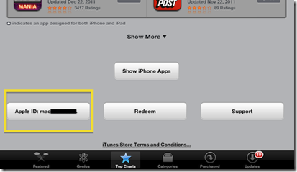
- Tap on the ID.
- Tap Sign Out on the pop up menu.
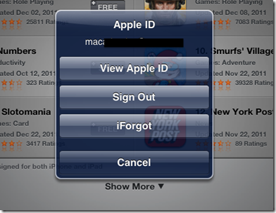
- Sign in with another ID.

