Article: Wordpress, how to hide the Screen Options tab
Date: 19/03/2012
Posted by: HeelpBook Staff
Source: Link
Permalink: Link

WordPress – How to Hide the Screen Options Tab
This tip comes to your courtesy of our friends over at WP-Snippets.com. When it comes to WordPress post editing, sometimes the fewer options for tinkering with, the better.
There are users who can get confused by all that’s available in the editor.

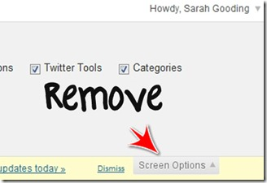

This snippet of code will completely remove the Screen Options tab from the administrator area.
Drop this into the functions.php file of your theme:

// Hide admin 'Screen Options' tab
function remove_screen_options_tab()
{
return false;
}
add_filter('screen_options_show_screen', 'remove_screen_options_tab');

