Date: 17/06/2012
Procedure: Windows Server 2008 - How to Disable Shutdown Event Tracker
Source: LINK
Permalink: LINK
Created by: HeelpBook Staff
Document Version: 1.0

Windows Server 2008 – How to Disable Shutdown Event Tracker

By default, Microsoft Windows Server 2008 makes you give it a reason for shutting down by prompting you with a “Shutdown Event Tracker” window whenever you shut the system down. This window forces users to type a comment in order to proceed with the shut down process. If you don’t use this feature and would like to disable it, you can do so with these steps.

1. Select Start > Run and type gpedit.msc, then click OK.

2. Expand Computer Configuration > Administrative Templates > System.

3. While System is selected, move to the right pane and scroll all the way down past the folders and to the individual policy options. You will have an option for Display Shutdown Event Tracker.

4. Double-click it.
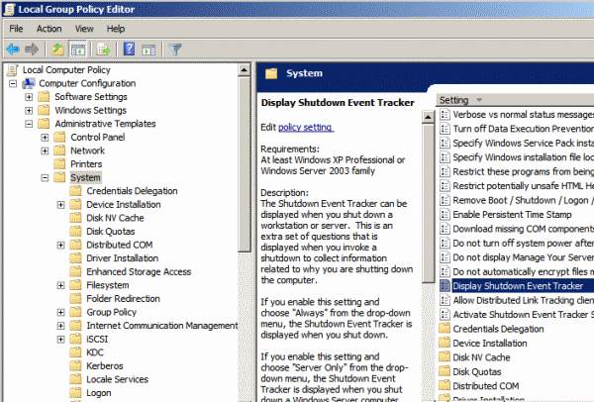

Note: People often swear this setting is not located in this area. Look closely if you’re one of these people. Scroll down past the folders or click the Setting bar to sort the row differently. It’s there!

5. Set it to Disabled, then click OK.

Now the annoying prompt will no longer appear when you shut down Windows Server 2008.

