Date: 03/07/2012
Procedure: Install Software CAB File to Pocket PC / Smartphone
Source: LINK
Permalink: LINK
Created by: HeelpBook Staff
Document Version: 1.0

Windows Mobile – Install Software CAB File to Pocket PC / Smartphone

Most software for Windows Mobile devices (Pocket PCs, touchscreen Windows Mobile Smartphones and non-touchscreen Windows Mobile Smartphones) is downloaded as an executable .EXE file. These files run within Windows, then install themselves on your Pocket PC or Windows Mobile Smartphone via ActiveSync.
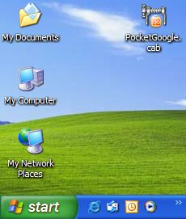

Sometimes, however, a program is downloaded as a .CAB, or cabinet, file. These files are designed to run and install themselves within Windows Mobile, and must be transferred to your Pocket PC or Smartphone before they can be installed.
In this tutorial, we’ll show you how to install applications distributed as .CAB files on yourWindows Mobile device.
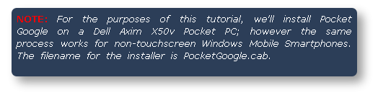

Step 1: Moving the .CAB File to Your Windows Mobile Device

Our first step is simply transferring the .CAB file to the Windows Mobile handheld. The installer file PocketGoogle.cab is located on our Windows desktop.

To begin, connect the handheld to your Windows PC using a USB cable or cradle. Allow the synchronization process to complete. Inside ActiveSync, click the Explore button on the toolbar:

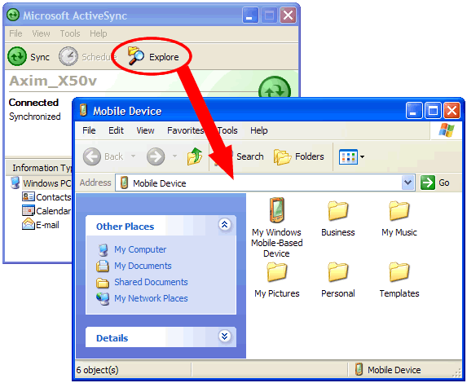

The Explore feature of ActiveSync is very useful; it provides access to the files stored on your Pocket PC or Windows Mobile Smartphone inside of the Windows OS.

With the Mobile Device screen open on your desktop, left-click and hold the .CAB file, and drag it to the Mobile Device screen, then release the mouse button:
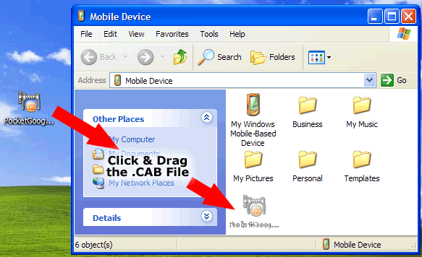

That’s it. The file has now been transferred to the mobile device.
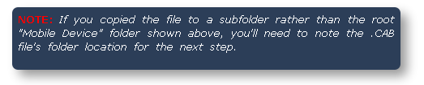

Step 2: Install the .CAB File’s Software

Now that the .CAB file has been copied to your Windows Mobile device, we’re ready to install the program.
On the handheld, tap Start > Programs > File Explorer. If you followed the instructions above and moved the file to the root Mobile Device window, navigate to the My Documents folder:

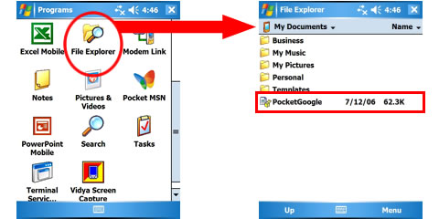

You should see the file you transferred in the My Documents folder. When you find it, tap it with your stylus (or, on a non-touchscreen smartphone, highlight the file and hit the OK key).

The .CAB file will begin the installation process. Follow the instructions on screen, which may vary from program to program:
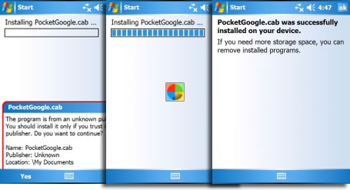

Your software has now been installed and is ready to use:
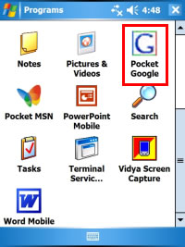

Final Thoughts

In some cases, opening a .CAB file and installing the software contained within will cause the file to be deleted when the installation process is complete. In other cases, you’ll need to manually delete the .CAB file using File Explorer. Leaving the .CAB file in your handheld’s memory will take up space, but is perfectly safe.

If you’re more comfortable moving files to your Windows Mobile device using a flash memory card and a memory card reader, feel free to do so. This tutorial covered the ActiveSync method of transferring files in the interests of universality (since some users don’t have card readers in their PCs).

It is also possible to download software contained within a .CAB file directly to your Windows Mobile Pocket PC or Smartphone from the Internet. If you download the .CAB file directly to your device, simply begin at Step 2 to install the software if it doesn’t install automatically.

