Article: Windows 7 – Simple Virtual Desktops
Date: 05/02/2012
Posted by: HeelpBook Staff
Source: Link
Permalink: Link

Windows 7 – Simple Virtual Desktops
I’ve always felt like Windows would benefit from a native virtual desktop implementation, but that is something Microsoft has yet to provide. There are plenty of third-party apps that can add this to just about any Windows operating system, but more often than not they aren’t that great.
The free (and open source) WindowsPager, on the other hand, is so easy to use that it’s definitely something you’ll want to try out.
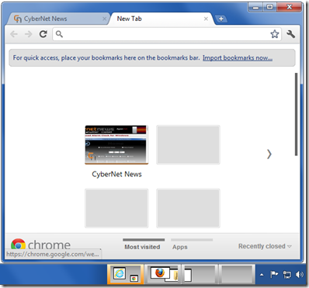

The screenshot above shows the main interaction you’ll have with WindowsPager, which is the small previews displayed in the Taskbar. The best feature is that you can directly interact with these previews including dragging-and-dropping windows from one virtual desktop to another all from within the previews.
You can even have a window span multiple virtual desktops if that’s what you want to do.

Of course those preview windows only represent one way that you can work with your virtual desktops. Here are the various ways you can interact with your virtual desktops:
- Switch to another desktop:
  - Click on the desktop in the Taskbar preview
  - Use the keyboard shortcut ‘Control-Win-NumpadNumber’ (NumLock must be active)
  - Go to the left/right desktop with ‘Control-Win-(Left/Right)-Arrow key’
- Move a window from one desktop to another:
  - Click on a mini-window for a short time until the cursor changed to a hand, now drag the mini-window from one preview-desktop to another
  - Use the windows menu (right click on window title or tasklist button) and select a “Move to …” item
  - Press ‘Control-Win-Alt-(Left/Right)-Arrow key’ to move the active window to the left/right(/above/below) desktop
  - Press ‘Control-Win-Alt-Numpad Key’, to move the active window to a certain desktop
- Set a window always visible:
  - Select “Always visible” from the window menu
- Set a window “on top” of all other windows:
  - Select “Keep on top” from the window menu
- Drag ‘n drop between desktops:
  - With the object selected (text file for example), hold the mouse for a short amount of time over a preview-desktop to switch to this desktop. You can not drop it directly to the pager window.
- MoveAndSwitch:
  - A new feature is to move a window to an other desktop and switch to this desktop automatically. To do this you must press the Control key during the use of the “Move to desktop X” menu.
WindowsPager Homepage (Windows only; Freeware)

