Article: How to check if TRIM is Enabled
Date: 10/01/2012
Posted by: HeelpBook Staff
Source: Link
Permalink: Link

How to find out if TRIM is Enabled and Working: After installing an SSD drive in your computer, you might wonder if trim is working. The Trim command allows the operating system to notify the SSD (solid state drive) of which data blocks are no longer in use so that they can be wiped. Similar to defragmenting a drive (which is not used on an SSD), Trim enables the SSD to handle garbage collection in an attempt to keep drive performance at a maximum.
How to Check if TRIM is Running in Windows
- (1) Click Start (2) Type cmd (3) right click cmd.exe and select Run as administrator;
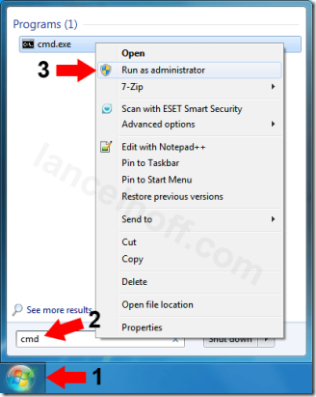
- Type fsutil behavior query DisableDeleteNotify into the Command Window and press Enter;
- If the result is DisableDeleteNotify = 0 then *Windows is set to send TRIM commands to the drive;
* = Note that the SSD drive must also support the ability to process TRIM commands sent to it, otherwise this setting is meaningless.
