Article: Windows 7 - Automatically Login and Lock
Date: 07/02/2012
Posted by: HeelpBook Staff
Source: Link
Permalink: Link

Windows 7 – Automatically Login and Lock
If you’re one of those people that have to suffer with a PC that takes minutes to boot up this is something you’ll want to consider doing. It can be frustrating when restarting a computer that takes forever because many times you can’t just walk away and come back to it ready to be used. Instead you have to wait for the computer to shutdown, restart, and then get back to the logon prompt so that it can continue loading everything that it needs to.

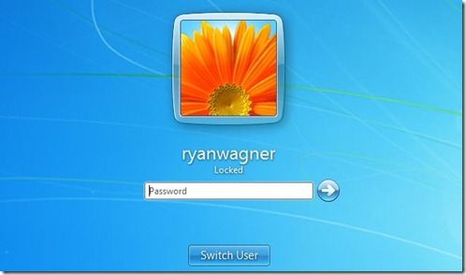

Give a warm welcome to Auto Logon & Lock. This package contains a couple files that need to be added to your Windows directory as well as a quick Registry script that needs to be run. It will only take you a minute to set this up, but once you have you’ll likely wish you had done it sooner.
With it in place your computer will automatically login to Windows using your account, but before the Explorer shell even loads the computer will be locked.
That means all of your apps will continue loading and be ready for you once you return.
The developer says that this will even protect the computer in Safe Mode, and at no point is your computer left “open” since it is locked before the Explorer shell loads. That means you’re able to reap the benefits with putting your machine at risk.
Pretty sweet.

Why To Use This
Some of the reasons you might want to do this are:
- Faster boot time. The additional post-logon start up items are also started after Windows boots. Which means when you press the power button on your PC and come back after a few minutes, its COMPLETELY booted up. No need to wait for additional software to load after you logon.
- Automatically resume downloads etc. - When your PC reboots due to a power failure or crash. On XP you could do this by installing the application as a system service. In Vista and 7, Session 0 Isolation makes using a system service a pain, not to mention it's insecure. Just put your applications in the regular Windows Start Up folder and they will be launched after the auto logon.
- It password protects Safe Mode as well. Existing auto logon methods leave Safe Mode unprotected.
- It locks the desktop before Explorer is started. Other methods auto-lock using an autorun/start up entry which leave the PC logged on and unlocked until the autorun entries are executed (which can even take several minutes).

