Article: How To Quickly Empty Recycle Bin From All User Accounts
Date: 07/02/2012
Posted by: HeelpBook Staff
Source: Link
Permalink: Link

Windows 7/8 – How To Quickly Empty Recycle Bin From All User Accounts
SCENARIO
On one of my test computers I run Windows 7 Ultimate edition and have created three user accounts to easily share that PC with my family. Except my user account, rest two accounts do not have a password. So, I can easily access other accounts, if required.

Recently I noticed that the “C:” drive was running out of free space and so decided to free up some disk space by emptying Recycle Bin and then deleing other junk files on my desktop. To empty Recycle Bin present in other accounts, I decided to use a good old command that lets you easily empty Recycle Bin from all user accounts in a jiffy.
The command comes in handy if you are the administrator of a multi-user Windows 7 or Windows 8 computer.
In this guide, I will show you how to use the Command Prompt to easily empty Recycle Bin from all user accounts:
IMPORTANT: Use this command with caution. Executing wrongly typed command may cause damage to your system and data.
Procedure
- Step 1: Launch elevated Prompt. To do this, type CMD in Windows 7 Start menu search box and simultaneously press Ctrl + Shift + Enter keys. Windows 8 users can simply type CMD in Start screen and then press Ctrl + Shift + Enter to launch Command Prompt with admin rights.
- Step 2: In the elevated prompt, type the following command:

rd /s c:\$Recycle.Bin
(In the above command, “c:” is your Windows drive)
- Press Enter key.
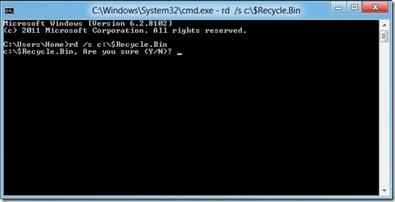

Press Y key to confirm and empty Recycle Bin. You are done! Type Exit and press enter key again to close the prompt.
There might be some other third-party tools to do this job, but this is the easiest way to empty Recycle Bin and free up some disk space. We tested this command in Windows 8 as well and can confirm that it works!

