Article: What is a Wind Farm?
Date: 03/01/2012
Posted by: HeelpBook Staff
Source: Link
Permalink: Link

What is a Wind Farm?

A wind farm is a collection of windmills or turbines which are used to generate electrical power through their mechanical motions as they are pushed by the wind. Both Europe and the United States have large numbers of wind farms, and the technology is also found on other continents. In Asia, India especially has devoted a great deal of funding to establishing wind farms. The energy generated by a wind farm can be fed directly into the general energy grid after passing through transformers.
As a potentially large source of renewable energy, wind farms are particularly popular in nations which are focusing on alternative energy. Other types of renewable energy include wave power and solar arrays. All of these technologies take advantage of already existing energy, converting it into a usable form. Since a wind farm does not actively deplete resources as it generates power, it is considered a form of “green” energy.
Naturally, some resources must be expended to create a wind farm. The turbines, transformers, and grid system on a wind farm are often made from less than ideal substances, such as metals mined in an unclean way. However, once installed, a wind farm requires no additional energy output other than that required for basic maintenance. This is a marked contrast to a power plant which relies on coal or petroleum products. Consumers who want to support wind farms can buy energy credits which go to developers of wind farms.

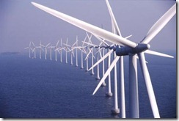

Naturally, the best place for a wind farm is a windy location. In some instances, a windy location may also be generally unusable or uninhabitable. In other instances, a wind farm may take up useful real estate which could be used for farming. This has led to some criticism of wind farms, since they take up a great deal more space than a comparable non-renewable energy generating facility.

In addition, wind farms pose a severe threat to migratory birds, as has been clearly documented by several scientific organizations.

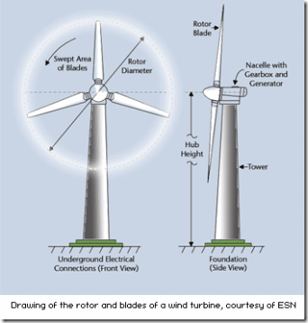

These issues aside, the technology is generally believed to be environmentally sound and fiscally viable.
Especially if wind farms are combined with other renewable energy sources, green energy could make up a bulk of the power grid. This could have a huge impact on the environment and on society in general.
Especially at the end of the twentieth century, when a growing number of citizens began to call for energy reforms, wind farms held a great deal of promise.

