# C:\Users\stefano.maggi.CONBIPELSPA\hbfaceopt.pngC:\Users\stefano.maggi.CONBIPELSPA\Desktop\prom38.png[**What is a Redirection Operator?**](http://heelpbook.altervista.org/2015/what-is-a-redirection-operator/)

**Visit Us:** [**http://www.heelpbook.net**](http://www.heelpbook.net/)

**Follow Us:**

[**https://twitter.com/HeelpBook**](https://twitter.com/HeelpBook)

**Date**: 01/04/2015

**Source:** [**LINK**](http://pcsupport.about.com/od/termsr/a/redirection-operator.htm)

**Permalink:** [**LINK**](http://heelpbook.altervista.org/2015/what-is-a-redirection-operator/)

**Document Version:** 1.0

**Total Chars**: 1129

**Total Words**: 219

**Created by:** HeelpBook

**Page:** 1



A **redirection operator** is a special character that can be used with a command, like a **Command Prompt** command or DOS command, to either redirect the input to the command or the output from the command.

By default, when you execute a command, the input comes from the keyboard and the output is sent to the **Command Prompt** window. Command inputs and outputs are called**command handles**.

The table below lists all of the available redirection operators for commands in **Windows**and **MS-DOS**. However, the > and >> redirection operators are, by a considerable margin, the most commonly used.

[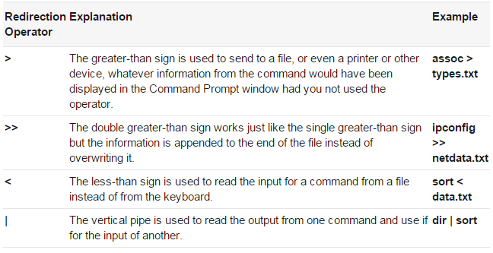](http://heelpbook.altervista.org/2015/what-is-a-redirection-operator/7823y4herw/)

**NOTE**: Two other redirection operators, **>&** and **< &**, also exist but deal mostly with more complicated redirection involving command handles.

**TIP**: The **clip**command is worth mentioning here as well. It’s not a redirection operator but it is intended to be used with one, usually the vertical pipe, to redirect the output of the command before the pipe to the **Windows Clipboard**. For example, executing **ping 192.168.1.1 | clip** will copy the results of the ping command to the clipboard, which you can then paste into any program.