Article: What Is a LAN?
Date: 03/01/2012
Posted by: HeelpBook Staff
Source: Link
Permalink: Link

What is a LAN?

LAN is acronyms of Local Area Network. LAN is required everywhere, whether it is office home or somewhere else. LAN is a small computer network (small version of internet) covering a small area like home, office building, school, college etc.
The important characteristics of LANs over WAN or Internet is higher data-transfer rates (up to 1 GBPS), smaller geographic region, and no need for leased telecommunication lines.
A LAN can be one of two kinds: wired or wireless. In wired LAN connection Ethernet (UTP) cable is physically connected to all computers on the network through a main device called a switch or hub. A WLAN (wireless LAN) uses radio waves to communicate thus eliminates the need for wires.
But WLAN is expensive than wired LAN.

LAN
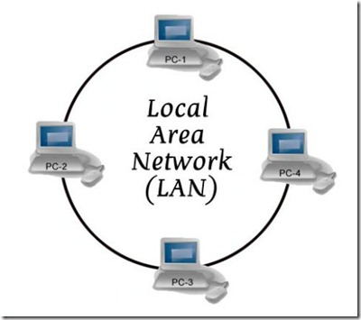

Advantages of LAN
A computer connected to a network significantly expands their capacity than a normal desktop because it has shared resources of all computers connected to network. Do your own two or more computers? By networking them, you can:
- Share a single Internet connection. In Windows XP you can share a single internet connection over a LAN. By sharing one Internet connection, you and your network users can simultaneously surf the web on their computer without interrupting other member on a different computer. This reduces your internet charge also. Buying internet for all family members is not required.
- Share a printer, scanner, and other hardware. Suppose you have a printer that is connected to a computer in another room of office or home. If you want to print a document, have to copy document onto a removable storage and take it to the computer that has the printer. With networking, you can print to this printer from your computer directly.
- Share files and folders. Suppose your friend or junior in office wanted you to check a document, he or she doesn’t need to carry that document from ground floor to 4th floor. When computers are networked together you can open the file from your computer, make changes, and then save the file on that computer without interrupting others.
- Play multi-computer games. By networking and sharing an Internet connection, networked computer members can play games on separate computers with each other or on the Internet with unknown players. And while they're playing online, one can surf the web, too — for example, checking emails, visiting stock exchange websites, checking current score of a cricket match.

Conclusion
These are few important advantages of LAN. There are lots more uses of LAN nowadays. Everyone use this for different purpose. If try to find its use in Enterprise sectors, it will be different from home use. So use of LAN varies from person to person.

