Article: What is a Directory or Folder?
Date: 22/02/2012
Posted by: HeelpBook Staff
Source: Link
Permalink: Link

What is a Directory or Folder?
The term comes up often in discussions but do you really know what a directory, subdirectory, or folder is?
A directory or folder is nothing more than a location on a disk used for storing information about files. With DOS 2.x, IBM/Microsoft introduced multiple directories on a single disk. In effect, this let you sort your files into groups and place each related group into its own directory. This means you don't have to search an entire disk to find one type of file; just the directory it is most likely in. Under Windows Microsoft started to use the term "folder" instead of "directory" but the two are interchangeable. [Note: Under Windows Vista you can also find files by typing part or all of their name into a search box on the Start menu. Vista keeps a catalog of where files are located for you.]
The root directory is exactly what the name implies: the most basic level in the directory tree.
A lower-level directory is called a subdirectory. If, instead of data, you created a file that pointed to other files on the disk, you will have built what amounts to a subdirectory.
If you look at a complete file name you see something like: C:\Program Files\Database\DBASE.EXE (or whatever). The root directory is the "C:\" part. "Program Files" is the next level. "Database" is a subdirectory under "Program Files", and "DBASE.EXE" is the actual file name.
As the name implies, a pathname is nothing more than a "path" that directs DOS to your particular file. The entire C:...EXE string above would be the full pathname.
In picture form, this is an example of a directory tree...

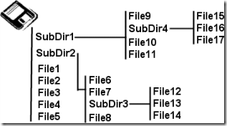

Note that you can have subdirectories inside of subdirectories. Indeed, under Windows it's quite common to have very deep directory trees with equally long pathnames. This can become a problem when the pathname approaches 256 characters in length.
Windows can have problems attempting to deal with names that long and has a current limit of 260 characters.

