Date: 16/01/2013
Procedure: Troubleshoot Power (energy) Management Settings (Windows 7)
Source: LINK
Permalink: LINK
Created by: HeelpBook Staff
Document Version: 1.0

Troubleshoot Power (energy) Management Settings (Windows 7)

Windows Vista includes a command line tool, Powercfg.exe, that you can use to configure power management settings.

Windows 7 introduces a new switch, /energy, to provide a comprehensive report of those settings.

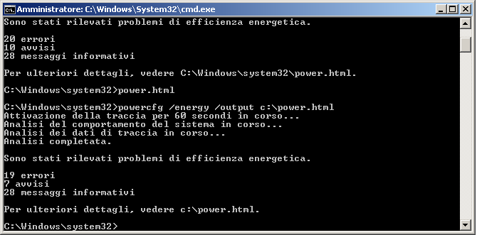

It also offers diagnostics that can indicate which applications or devices might be causing power management issues (such as a USB driver not entering suspend) and what power management settings you can configure differently for better results.

At an elevated command prompt, simply enter:
POWERCFG /ENERGY /OUTPUT "<full_path\filename>"
The tool will observe your computer for 60 seconds, and then create a file called, for example, ENERGY-REPORT.HTML in the path you specified.

Simply double-click on this file to see what’s going on.

