Date: 12/06/2013
Procedure: The origin of the term “pwned”
Source: LINK
Permalink: LINK
Created by: HeelpBook Staff
Document Version: 1.0

The origin of the term “pwned”

Pwn is a leetspeak slang term derived from the verb own, as meaning to appropriate or to conquer to gain ownership. The term implies domination or humiliation of a rival, used primarily in the Internet-based video game culture to taunt an opponent who has just been soundly defeated (e.g., “You just got pwned!”).
In hacker jargon, pwn means to compromise or control (but even destroy or conquer), specifically another computer(server or PC), web site, gateway device, or application. It is synonymous with one of the definitions of hacking or cracking, including iOS ing. The Pwnie Awards are awarded by a group of security researchers.

Popularity of the term among teenagers rose in the mid-2000s, with the spread from the Internet written form to use in spoken language.

Pwnage VS Pwned
You have seen this peculiar term online, with expressions like “I got pwned!”. Now, you hear it on the bus and in public as people speak about their personal lives. So what exactly does “pwned” mean? And is that the same a “pwnage”?
It can be pronounced as “owned” or as “poned”, with both pronunciations being correct.

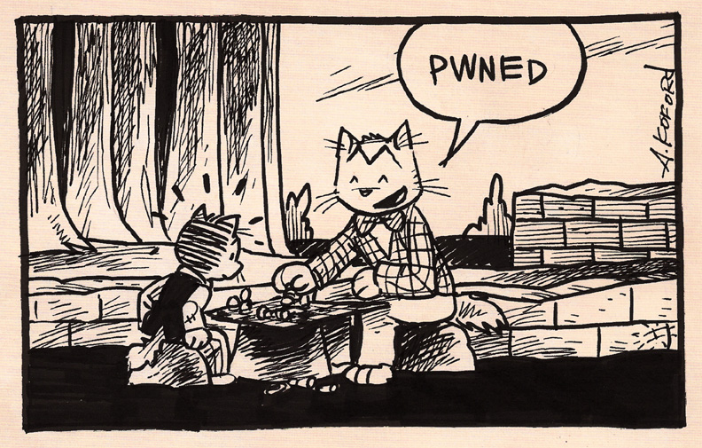
The origin of the term "pwned"

In some cases, you will even hear it pronounced as “pawned“. “Pwned” means “to be controlled against your will”, or “to be defeated by a superior power“. You might also hear the expression, “pwnage”, which is the noun version of “being pwned”.This “pwn” expression originated in the 1980′s from the word “owned“. It was used to describe when a hacker would take remote control of a server or another computer.

The use of “p” to replace “o” was simply a misspelling at first, but the spelling stuck as a stylistic point.

The (multiple) origin of the term
Normally, the word pwn seems most likely come about as a common typo (typing error) of the word own because the “p” and “o” keys are adjacent on a standard English (QWERTY) keyboard, but there is another etimology hypothesis about this term.

The term pwned could be born from the Chess game. The supposition is the following: the aim of the game of chess is to put the other player in , meaning, he is unable to move his king anywhere that he would not be threatened by another piece.
Also in this game, you have 8 pieces at the front of your army called ‘pawns‘, these were the least useful of all pieces, but that is not to mean they were worthless.
If you could defeat the other player by using your pawn to apply check, that was called, and is still calledpawned –> pwned.

Pwned…today
With today’s MMO games (massive multiplayer online games), the term “pwned” has now became a way to gloat in one’s victory over another player. Conversely, pwned is an expressive way to say that you yourself have been defeated by another player.

Some examples of this pwned expression in digital culture:
“I got pwned by those three horde players. They ganked me bad.”
“We pwned that other team, woot!”
“Hahaha! Jason got pwned in arena today!”
“That was total pwnage! We totally crushed that boss monster!”

Some examples of this pwned expression in daily life:
“That speeder got totally pwned by that radar trap cop!”
“We pwned that other basketball team!”
“Oh, man. I got totally pwned by the aerobics instructor in class today. That was so difficult!”
“Pwnage! I got an A on that exam! Woot!”

Indeed, digital culture has spilled over into daily life. It is common for the modern generation to use these expressive techno terms in daily conversation.

