Date: 26/12/2012
Procedure: “The System Could Not Access The Credential Manager Server” Error (Windows Vista)
Source: LINK
Permalink: LINK
Created by: HeelpBook Staff
Document Version: 1.0

“The System Could Not Access The Credential Manager Server” Error (Windows Vista)

Credential manager is a single sign-on feature that allows users to input user names and passwords for multiple network resources and applications. Credential Manager is a central store for all of your usernames, passwords, and X.509 certificates.

In Windows Vista, Credential Manager can roam stored user names and passwords between multiple computers in an active directory domain. For example, if a user logs on to acomputer and connects to a password protected web server and selects “Remember My Password” checkbox.

This information will be saved within the Credential Manager. When the user logs on to a different computer and connects to the same server, Internet Explorer will provide the password. So, the user is not supposed to type it again.
Earlier versions of Windows cannot access the stored credentials.

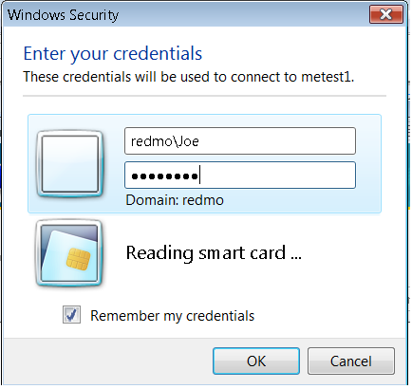

Those who use HP / Compaq line of desktops and laptops, you can find all of a sudden that can no longer access the system by displaying the following message: “The system could not access the Credential Manager Server“.

The problem is not for the Windows Vista operating system, but certainly one of the software pre-installed by the manufacturer that for most will never be used and that encumbers the eroding precious memory.

“The system could not access the Credential Manager Server” error occurs due to a software“HP ProtectTools Security Manager”,which can be configured to prevent unauthorized access using Smart Cards, TPM Embedded security chips, USB sticks.

There are two ways to solve the problem:

First solution:

- Reboot the PC. While it is being restarted by pressing the F8 function key. On the screen will display a different kind of start (If we do not even get the pc reboot and press the F8 function key faster;);
- Select “Start in Safe mode”;
- When you are prompted to log in using the local administrator account;
- Go to services and DISABLE everything that starts with HP;
- Reboot the system. Hit f10 while it’s starting and disable the security settings (the second colum halfway down). You’ll have to configure a password to do it for some reason.
- When you are prompted to log in using the local administrator account;
- Go to Start / all program / HP ProtectTool Security Manager FOR ADMINISTRATORS;
- Click on Credential Manager and then click Settings;
- Deselect the checkbox in the General tab “Use credential manager to log on to Windows”;
- You need to logoff;
- Select “Logon as a different user” and use a standard domain account.

Second Solution:

At the Windows Vista login screen, do the following:

- Choose “Log in as different user”;
- Click “log on with Wizard”.This will bring up a new login window where you can specify you username, Domain, and password.
- In the bottom left corner of this window is a button labeled “More” Click it, and check the box labeled “Do not logon to Credential Manager”;
- Write your username, password and domain in the respective places and log on.
- After successful logon, UNINSTALL CREDENTIAL MANAGER!
If you don’t, you will have to repeat the procedure next time you start up your PC again!

Sometimes this solution will works fine:

- Start in safe mode and log on as a local admin;
- Start device manager and look under ‘Security Devices’ for ‘TrustedPlatformModule’ – Right click and select uninstall;
- Reboot and allow the module to auto-reinstall itself;
You should now be able to logon to Windows Vista without receiving a credential manager error.
Depending on the versions of Windows Vista and TPM you are running you might have to re-register any finger scans you had stored.

The problem is the driver becomes corrupted.

