Date: 28/02/2013
Procedure: Summit Client Utility to configure Radio (WiFi) devices on Windows Mobile
Source: LINK
Permalink: LINK
Created by: HeelpBook Staff
Document Version: 1.0

Summit Client Utility to configure Radio (WiFi) devices on Windows Mobile

Using the Summit Client Utility
SCU is an application designed for end users and administrators of mobile devices that use a Summit radio module. Using SCU, an end user can:

- Disable the radio (turn it off) and enable the radio (turn it on).
- View the contents of configuration profiles.
- Select the profile to be used to connect to a WLAN.
- View global settings.
- View status information on the radio, the access point (AP) or WLAN router to which it is connected, and the RF connection or link between the two.
- View in-depth diagnostic information and perform troubleshooting and diagnostic tests.
After completing an administrator login to the utility, a user can perform these additional tasks:
- Create, rename, edit, and delete profiles.
- Edit global settings.
SCU provides a graphical user interface for access to all of its functions. Access to these functions also is available through an SDK that an application programmer can use to enable another utility to manage theradio.
To initialize SCU:

- From the Start menu, select Programs or All Programs (depending on your operating system).
- Select the Summit directory (which includes a directory for stored security certificates and an SCU icon).To run SCU, double-click the SCU icon.
SCU includes the following five windows: Main, Profile, Status, Diags (or Troubleshooting), and Global.

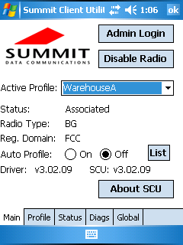

Main Window

- Admin Login/Logout - The default password isSUMMIT (case sensitive).
The password can be changed through the Admin Password function on the Global window.
- Enable/Disable Radio
- Active Profile - You can view the name of the active profile and, using the selection list, select a different profile. If you select ThirdPartyConfigthen, after the device goes through a power cycle, WZC is used for configuration of the radio.
- Status - Down, Disabled, Not Associated, Associated, Authenticated.
- Radio Type - A (802.11a), B (802.11b), G (802.11g), and/or N (802.11n).
- Reg. Domain - Indicates the regulatory domain for which the radio is configured. The domain cannot be configured by an administrator or user.
- Auto Profile - Enables the user to activate or deactivate an automatic profile selection facility.
Note: The profile list should not include any profiles with an Ad Hoc radio mode setting.
Note: Auto Profile is not available for the MSD30AG and SSD30AG modules.

- Driver - Indicates the version of the device driver that is running on the device.
- SCU - Indicates the version of SCU that is running on the device.
- About SCU - When tapped, supplies information on SCU that on a Windows application normally would appear under Help > About.
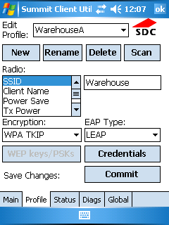
Summit Client Utility interface

Profile Window

Profile settings are radio and security settings that are stored in the registry as part of a configuration profile. When a profile is as the active profile on the Main window, the settings for that profile become active. An administrator can define up to 20 profiles, edit them, and delete them on the Profile window in SCU.

Note: Profile changes made on the window are saved to the profile only when you click Commit.

Unless it is modified, the Default profile does not specify an SSID, EAP type, or method of encryption. If the Default profile is the active profile, then the radio will associate only to an access point that broadcasts itsSSID and requires no EAP type and no encryption.

- Edit Profile - This is used to select the profile to be viewed or, if you are an administrator, edited.
- New - Tap to create a new profile (Admin only).
- Rename - Tap to give the profile a new unique name (Admin only).
- Delete - Tap to delete a non-active profile (Admin only).
- Scan - Tap to view access points that are broadcasting SSIDs. SCU allows an administrator to create a profile from a listed SSID.
- Radio - When an attribute is selected, the current setting or an appropriate selection box with the current setting highlighted appears on the right.
- Security - EAP type and encryption type display with the current values highlighted.
Administrators can define EAP type credentials as well as WEP keys or PSKs.
- Commit - Tap Commit to confirm changes made to the profile settings.
To cause a Summit radio to connect to a typical business WLAN, you must select a profile that specifies the SSID, EAP type, and encryption type supported by the WLAN:
- SSID – Name or identification of the WLAN.
- EAP type – Protocol used to authenticate the device and its user if the WLAN uses the Enterprise version of Wi-Fi Protected Access (WPA) and WPA2.
Encryption – Type of key used to encrypt and decrypt transmitted data and how that key is specified or derived. Encryption options include:

- WPA2 or WPA with dynamic keys
- WPA2 or WPA with pre-shared keys
- Static WEP keys
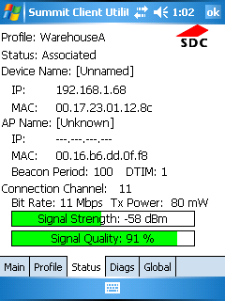
Summit Client Utility interface

Status Window
The Status window provides status information on the radio.
- Active Profile
- Radio’s status – Down (not recognized), Disabled, Not Associated, Associated, or [EAP type] Authenticated
- Client info – Name, IP address, and MAC address
- AP info – Name, IP address, MAC address, beacon period, and DTIM interval
- Connection info – Channel, data rate, transmit power, signal strength, and signal quality
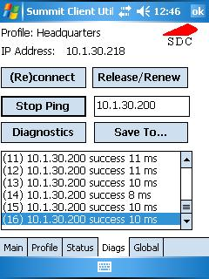
Summit Client Utility interface

Diags Window

The Diags window provides status information on the radio.
- (Re)connect - Disable and enable the radio, apply or reapply the current profile, and attempt to associate and authenticate to the wireless LAN, logging all activity in the output area at the bottom.
- Release/Renew - Obtain a new IP address through DHCP release/renew and log all activity in the output area at the bottom.
- Start Ping - Start a continuous ping to the address in the edit box next to it.
- Diagnostics - Attempt to (re)connect to an AP, and provide a more thorough dump of data than is obtained with (Re)connect. The dump includes radio state, profile settings, global settings, and a BSSID list of APs in the area.
- Save To… - Save the diagnostics output to a file.

Global Window

Global settings include:
- Radio and security settings that apply to all profiles;
- Settings that apply to SCU itself;
An administrator can define and change most global settings on the Global window in SCU.

