Date: 14/11/2012
Procedure: Simple ABAP program (SAP)
Source: LINK
Permalink: LINK
Created by: HeelpBook Staff
Document Version: 1.0

Simple ABAP program (SAP)

One of main job of an ABAP-er is create ABAP report. Report content 4 basic component:

1. Data declaration.
2. Selection screen.
3. Select Data.
4. Write Report.

I assume you already familiar with data dictionary. For an example, we have a table “SFLIGHT“, with following fields:

1. CARRID (Airline carrier ID)
2. CONNID (Flight connection Id)
3. FLDATE (Flight date).
4. SEATSMAX (Maximum capacity).

We wan to create a report that can be filtered based on Airline carrier ID and Flight connection Id.

Go to transaction code SE38 (SAP Menu->Tools>ABAP Workbench->Development->ABAP Editor), enter program name with prefix Z, for example ZTEST0001, then choose “Create” button.

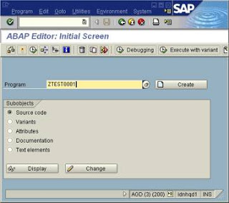

Then, enter title for program, and choose 1 “Executable Program” for program type. If screen input for development class appear, click “Local Object“.

Then, go to following steps.

1. Data declaration
TABLES: sflight.
DATA: BEGIN OF t_report OCCURS 3,
carrid LIKE sflight-carrid,
connid LIKE sflight-connid,
fldate LIKE sflight-fldate,
seatsmax LIKE sflight-seatsmax,
END OF t_report.

2. Selection screen
SELECT-OPTIONS s_carrid FOR sflight-carrid.
SELECT-OPTIONS s_connid FOR sflight-connid.
It will generate selection screen like picture below.
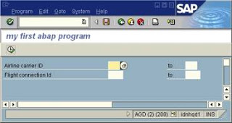

3. Select data
SELECT * FROM sflight
WHERE carrid IN s_carrid AND
connid IN s_connid.
t_report-carrid = sflight-carrid.
t_report-connid = sflight-connid.
t_report-fldate = sflight-fldate.
t_report-seatsmax = sflight-seatsmax.
APPEND t_report.
ENDSELECT.
IF sy-subrc NE 0. “sy-subrc = return code
WRITE ‘Data not found’.
ENDIF.

4. Write data
LOOP AT t_report.
”comment: Go to next line
skip.
WRITE t_report-carrid.
WRITE t_report-connid.
WRITE t_report-fldate.
WRITE t_report-seatsmax.
ENDLOOP.
The result:
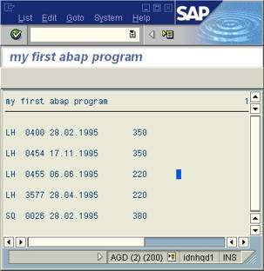

Here is the complete program:

REPORT ZTEST0001 .
*Data Declaration
tables: sflight.

DATA: BEGIN OF t_report OCCURS 3,
carrid LIKE sflight-carrid,
connid LIKE sflight-connid,
fldate LIKE sflight-fldate,
seatsmax LIKE sflight-seatsmax,
END OF t_report.

*Selection Screen
SELECT-OPTIONS s_carrid FOR sflight-carrid.
SELECT-OPTIONS s_connid FOR sflight-connid.
*Get Data
SELECT * FROM sflight
WHERE carrid IN s_carrid AND
connid IN s_connid.
t_report-carrid = sflight-carrid.
t_report-connid = sflight-connid.
t_report-fldate = sflight-fldate.
t_report-seatsmax = sflight-seatsmax.
APPEND t_report.
ENDSELECT.
IF sy-subrc NE 0.
WRITE ‘Data not found’.
ENDIF.
*Write Data
LOOP AT t_report.
skip. “comment:Go to next line
WRITE t_report-carrid.
WRITE t_report-connid.
WRITE t_report-fldate.
WRITE t_report-seatsmax.
ENDLOOP.

