# **Significant Figures**C:\Users\stefano.maggi.CONBIPELSPA\hbfaceopt.pngC:\Users\stefano.maggi.CONBIPELSPA\Desktop\prom38.png

**Visit Us:** [**http://www.heelpbook.net**](http://www.heelpbook.net)

**Follow Us:**

[**https://twitter.com/HeelpBook**](https://twitter.com/HeelpBook)

**Date**: 28/11/2014

**Source:** [**LINK**](http://www.usca.edu/chemistry/genchem/sigfig.htm)

**Permalink:** [**LINK**](http://heelpbook.altervista.org/2014/significant-figures/)

**Document Version:** 1.0

**Total Chars**: 1546

**Total Words**: 275

**Created by:** HeelpBook

**Page:** 1



**Significant figures** are critical when **reporting scientific data** because they give the reader an idea of how well you could actually **measure/report** your data.

Before looking at a few examples, let’s summarize the rules for significant figures.

1. ALL non-zero numbers (1,2,3,4,5,6,7,8,9) are **ALWAYS**significant.
2. ALL zeroes between non-zero numbers are **ALWAYS**significant.
3. ALL zeroes which are **SIMULTANEOUSLY**to the right of the decimal point AND at the end of the number are **ALWAYS**significant.
4. ALL zeroes which are to the left of a written decimal point and are in a number >= 10 are **ALWAYS** significant.

A helpful way to check rules 3 and 4 is to write the number in scientific notation. If you can/must get rid of the zeroes, then they are NOT significant.

# **Examples: How many significant figures are present in the following numbers?**

[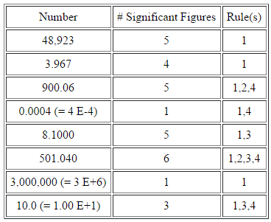](http://heelpbook.altervista.org/2014/significant-figures/kfkof/)

# **Addition and Subtraction**

When adding or subtracting numbers, count the **NUMBER OF DECIMAL PLACES** to determine the number of significant figures.



The answer cannot **CONTAIN MORE PLACES AFTER THE DECIMAL POINT THAN THE SMALLEST NUMBER OF DECIMAL PLACES** in the numbers being added or subtracted.

[[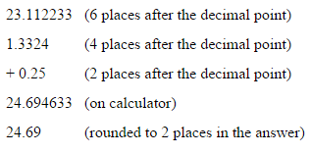](http://heelpbook.altervista.org/2014/significant-figures/kflsjdf/)](http://heelpbook.altervista.org/2014/significant-figures/kflsjdf/)

# **Multiplication and Division**

When multiplying or dividing numbers, count the **NUMBER OF SIGNIFICANT FIGURES**.

The answer cannot **CONTAIN MORE SIGNIFICANT FIGURES THAN THE NUMBER BEING MULTIPLIED OR DIVIDED** with the **LEAST NUMBER OF SIGNIFICANT FIGURES**.

[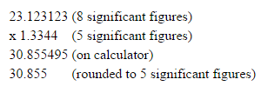](http://heelpbook.altervista.org/2014/significant-figures/jjoj/)

**Visit Us:** [**http://www.heelpbook.net**](http://www.heelpbook.net)

**Follow Us:**

[**https://twitter.com/HeelpBook**](https://twitter.com/HeelpBook)

**Date**: 28/11/2014

**Source:** [**LINK**](http://www.usca.edu/chemistry/genchem/sigfig.htm)

**Permalink:** [**LINK**](http://heelpbook.altervista.org/2014/significant-figures/)

**Document Version:** 1.0

**Total Chars**: 1546

**Total Words**: 275

**Created by:** HeelpBook

**Page:** 2

