Date: 25/02/2013
Procedure: Scrolling the Windows Command Prompt With Only the Keyboard
Source: LINK
Permalink: LINK
Created by: HeelpBook Staff
Document Version: 1.0

Keyboard Ninja – Scrolling the Windows Command Prompt With Only the Keyboard

The Windows command prompt (cmd.exe) has always been known for being underpowered compared toLinux, but have you ever noticed that to view the output of a long command you have to resort to themouse to scroll?

You can easily scroll with just the keyboard, but to get into the “Scroll Mode” you’ll have to use a 4-key combination that reminds me of cheat codes on old nintendo games… Up, Up, Down, Down…

Press Alt+Space together, and then E, then L
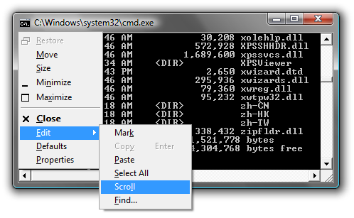
Enable Scroll Mode on MS-DOS
This will put the command prompt into “Scroll” mode, where you can use the Page Up/Down keys as well as the arrow keys.

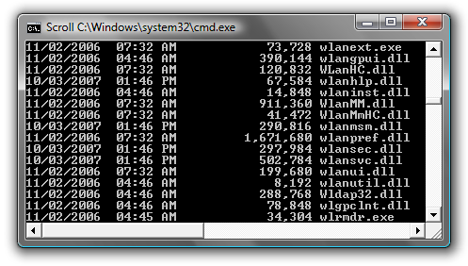
Enable Scroll Mode on MS-DOS

To get out of this mode, you can hit the Esc or Enter keys.

One of the most annoying instances of this problem is when trying to view the output of the ipconfigcommand… it always stretches beyond the current page on my system… now I can finally use the keyboard.

