Article: sp_refreshview for all views in a DB
Date: 15/12/2011
Posted by: HeelpBook Staff
Source: Link
Permalink: Link

SQL Server - Sp_refreshview for all views in a Database

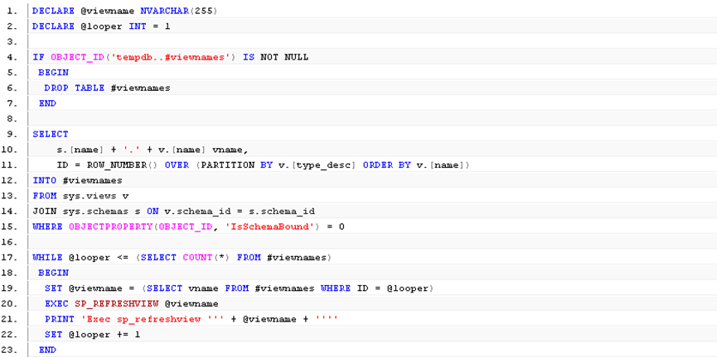
Run in the context of each database as a nightly or weekly job depending on how often your non-schemabound views and underlying tables are altered.

DECLARE @viewname NVARCHAR(255)
DECLARE @looper INT = 1
IF OBJECT_ID('tempdb..#viewnames') IS NOT NULL
BEGIN
DROP TABLE #viewnames
END
SELECT
s.[name] + '.' + v.[name] vname,
ID = ROW_NUMBER() OVER (PARTITION BY v.[type_desc] ORDER BY v.[name])
INTO #viewnames
FROM sys.views v
JOIN sys.schemas s ON v.schema_id = s.schema_id
WHERE OBJECTPROPERTY(OBJECT_ID, 'IsSchemaBound') = 0
WHILE @looper <= (SELECT COUNT(*) FROM #viewnames)
BEGIN
SET @viewname = (SELECT vname FROM #viewnames WHERE ID = @looper)
EXEC SP_REFRESHVIEW @viewname
PRINT 'Exec sp_refreshview ''' + @viewname + ''''
SET @looper += 1
END

