Article: SQL Server - Subqueries
Date: 21/12/2011
Posted by: HeelpBook Staff
Source: Link
Permalink: Link

SQL Server - Subqueries
You've seen the Russian dolls where you've got one doll, inside another, inside another, etc.?
A SQL subquery is very much like this; it's tucked inside other commands, or even other SQL subqueries.
They may be placed inside one of the following commands:
- SELECT
- SELECT…INTO
- INSERT…INTO
- DELETE
- UPDATE
Subqueries are used to refine a SQL query when you'd rather just use one operation to find out what you need to know rather than two. This is best when you are planning to use a particular query over again in the future, as for a monthly sales figure or other regular metric.

Using SQL Subqueries
Sometimes when you're working on a SQL query, you find that you need to find out something else to finish your operations properly. For instance, suppose you need to find the top customers at your grocery store who have shopped during a certain period? Or the opposite, find among customers who have shopped during a certain period which spend the most money?
A SQL subquery is perfect for finding out this information. In plain English, your command would be something like "Select the best customers Where (Select customers who shopped during January)" .
Assuming you have your top customers segregated in a second table, in SQL code this would translate to:

SELECT "TopCustomer" WHERE (SELECT "shoppingdate" = "October")

Another example is when you need to copy a table or portion of a table into a new table so you can perform other operations on it.

INSERT INTO TableNew SELECT TableNeeded

Where this gets really confusing is when you start nesting subquery after subquery. Like the Russian dolls, you can insert new subqueries for as long as you can keep track of them. Most SQL programmers are creating subqueries long before they start to use them.
It's just that most people create new tables from the nested query to perform the operations in the outside query before actually compiling subquery statements.

Three Types of Subquery
Subqueries can form three types of statements:
- Comparison: involving ANY, ALL, or SOME, this subquery compares an expression with the results of a subquery;
- Expression: Subqueries starting with [NOT] IN have their results searched for a particular expression;
- Sql statement: This is a standard SELECT statement. It starts with [NOT] EXISTS;
Syntax will be as follows:

SELECT "column_name1"
FROM "table_name"
WHERE "column_name2" [Comparison Operator]
(SELECT "column_name1"
FROM "table_name"
WHERE [Condition])

The comparison operator can be -+/* or any word comparison such as LIKE. You should notice that the Column Name for each SELECT operation should be the same, though the table name can vary.

Examples:
A retail store has been losing money by offering its customers too many discounts. In order to control discounts on a product, you might need to know which items you were running a 10%, 20%, or 30% discount on.
Your SQL query would look something like this:

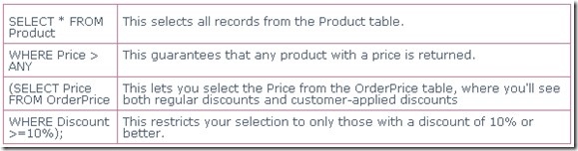

You would have returned in the new table every record that has a discount price of 10% or more. If you needed to change the discount percentage, that's easy to do.
You could even do the discount by dividing the original price by the actual sale price; it would simply require inserting a new subquery in the 10% spot performing that operation.

