Date: 10/05/2012
Procedure: SQL Server - Server is not configured for RPC (Remote Procedure Calls)
Source: LINK (http://lordfu.wordpress.com/2010/04/23/server-is-not-configured-for-rpc/)
Permalink: LINK
Created by: HeelpBook Staff
Document Version: 1.0

SQL Server – Server is not configured for RPC (Remote Procedure Calls)

I was setting up a new database on a new SQL Server 2005 installation that has a few linked servers configured (which happen to be SQL Server 2000), while testing execution of a remote stored procedure it failed with the error:

Msg 7411, Level 16, State 1, Line 1
Server 'psp6new' is not configured for RPC.

The problem was that RPC was not configured for the linked server. this is not set by default, you can see what settings are configured with:

exec sp_helpserver

If ‘rpc and rpc out’ are not in the results, then the the linked server isn’t configured for RPC. To do so:

exec sp_serveroption @server='myserver', @optname='rpc', @optvalue='true'
exec sp_serveroption @server='myserver', @optname='rpc out', @optvalue='true'

Or alternatively you can right click on your linked server bring up it’s properties and select True for the value from the RPC and RPC Out rows.
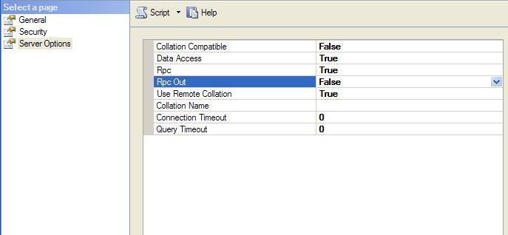
Hope this helps!

