Article: Running VBScript from T-SQL
Date: 16/02/2012
Posted by: HeelpBook Staff
Source: Link
Permalink: Link

SQL Server – Running VB Script From TSQL
In this post we will see if we can run a VB Script from SQL Server. Yes, SQL Server allows to run external scripts. So, here is the process how to run a VB Script from T-SQL Code.
Well to test this lets first create a sample VB Script which will just display a message.

Dim VarSetMessage
VarSetMessage = "Running VB Script from SQL Server..."
'Display message
WScript.Echo VarSetMessage

Save it as “myMsg.vbs” on “C:\” drive of your machine. Okey, before running this script from SQL Server, lets see how to run it from Command Prompt. To do this:

Start => Run => cmd => ENTER
Type Cscript C:\myMsg.vbs => ENTER

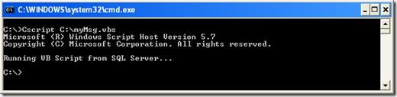

Now to run the VB Script from SQL Server just run the same command line we tested above using xp_cmdshell from SQL Server.

EXEC XP_CMDSHELL 'CScript C:\myMsg.vbs'

and we are done !!!
Note: You may need to configure xp_cmdshell if not configured before.

