Article: Get Date Part Only from Datetime
Date: 20/01/2012
Posted by: HeelpBook Staff
Source: Link
Permalink: Link

SQL Server - Get Date Part Only from Datetime
I have seen scores of expert developers getting perplexed with SQL Server in finding time only from datetime datatype. Let us have a quick glance look at the solution.

SQL Server 2000/2005

SELECT
CONVERT(VARCHAR(8),GETDATE(),108) AS HourMinuteSecond,
CONVERT(VARCHAR(8),GETDATE(),101) AS DateOnly
GO

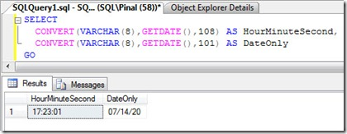

SQL Server 2008

SELECT
CONVERT(TIME,GETDATE()) AS HourMinuteSecond,
CONVERT(DATE,GETDATE(),101) AS DateOnly
GO

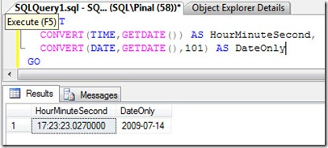

I hope the above solution is clear to you all.

