Date: 12/04/2012
Procedure: Outlook - Unblock Attachments
Source: LINK (http://www.howto-outlook.com/faq/blockedattachments.htm)
Permalink: LINK (http://heelpbook.altervista.org/2012/outlook-unblock-attachments/)
Created by: HeelpBook Staff
Document Version: 1.0

Outlook – Unblock Attachments

Believe it or not but some people are actually creating and sending messages with attachments that will do your computer no good. Yes, you are correct; VIRUSES! There are a lot of file types in which a virus can reside. The most known are executables (programs) and scripts (automated processes). A filename consists out of 2 parts; a name and an extension. The extension is the part of the filename after the dot. For instance the filename document.doc. Document is the name part and doc is the extension part. The last part decides how the file opens.
In our example a doc file will open with Microsoft Word.

At the moment there is a limited (but not a definite) list of file extensions that are known to be potential viruses. Outlook takes no chances and blocks these files whether or not it contains a virus because Outlook is not a virus scanner and therefore cannot determine whether the file is save or not.

This is actually a good thing; even unknown viruses will be blocked this way! The downside of this is that occasionally you could receive a file that you know is clean but still can’t access. For instance; you receive a little (Flash) game or other program by e-mail.

Outlook informs you about any blocked attachments in the message header

Unblocking procedure

Before I tell you how you can still access those attachments you must realize that you are creating a security risk on your computer this way. A good practice is to send these files in a compressed (for instance zip or rar) format. This enables you to scan the file before unpacking and it will also take less inbox space and upload/download time!
To enable receive blocked attachments involves changing the registry. I strongly recommend to only edit the registry when you actually receive a blocked attachment and there is no other way in getting that file again in a safer way (in compressed format) and you know for sure that the file is clean.
Also, change back the registry directly after you saved the attachment. It probably sounds paranoid but you’ll be hitting yourself if you get infected because you "opened the door and invited the virus" yourself.
Alright, here goes;
• Make sure Outlook is closed.
• Open your registry editor by opening the Run command and type regedit (regedt32 forWindows 2000).
In Windows Vista and Windows 7 you can also directly type regedit in the Start Menu’s Search box.

• Locate the following key:
Outlook 2000
[HKEY_CURRENT_USER\Software\Microsoft\Office\9.0\Outlook\Security]
Outlook 2002
[HKEY_CURRENT_USER\Software\Microsoft\Office\10.0\Outlook\Security]

Outlook 2003
[HKEY_CURRENT_USER\Software\Microsoft\Office\11.0\Outlook\Security]
Outlook 2007
[HKEY_CURRENT_USER\Software\Microsoft\Office\12.0\Outlook\Security]
Outlook 2010
[HKEY_CURRENT_USER\Software\Microsoft\Office\14.0\Outlook\Security]
• Go to Edit-> New-> String Value and name the value Level1Remove (case sensitive!)
• Double-click on the newly created value and enter the extension including the "dot" that you want to open in Outlook. For instance .exe; If you need to enter more than one extension you’ll have to type separate them by a semicolon like this; .exe;.bat;.url;
• Press OK on the input box and close the registry editor;
• When you open now Outlook, the attachments which hold those extensions aren’t blocked by Outlook anymore.

To let Outlook block those extensions again follow the instructions again but instead of creating the Level1Remove value delete it.

If you are not comfortable with manually editing the registry or prefer easier access to block/unblock attachments you can also use OutlookTools (free).
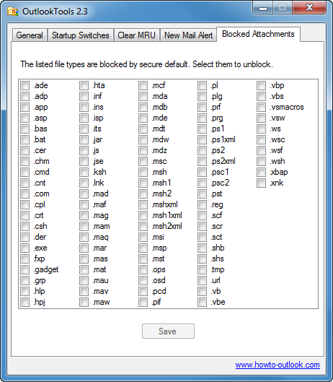
Easily unblock (and then block again) attachments with OutlookTools.

Again; change back the registry directly after you saved the attachment or you’ll leave a door open for infecting your computer with a virus!

List of blocked attachments

This is the list of file types that are blocked by Outlook (click here for the latest list published by Microsoft).

