Date: 06/08/2012
Procedure: Outlook 2010 - How to Password Protect your mail
Source: LINK
Permalink: LINK
Created by: HeelpBook Staff
Document Version: 1.0

Outlook 2010 – How to Password Protect your mail

Microsoft Outlook provides you with the flexibility to read your emails offline. While this is a wonderful convenience, it can at times be a problem. For instance somebody using your computer can simply open up Outlook and read all the messages in your inbox.

You could configure the settings of Outlook such that a password is required each time the app tries to sync inboxes but that would only prevent others from reading new email. Email that has already been downloaded will be open to anybody who is using your computer under your Windows username.
What you need is a way to complete password-protect Microsoft Outlook. And if you are using the 2010 version of Outlook, then you are in luck. Microsoft Outlook 2010 lets you store your main data files in a particular location. This location is opened before any others. By password-protecting this main data folder you can effectively password protect Microsoft Outlook.

How to Password Protect Microsoft Outlook 2010

Step 1: Enter account settings from the File menu in the top left.
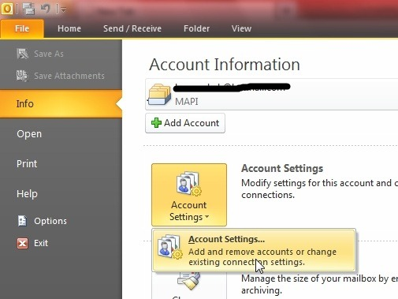
Step 2: A new window will open up with different tabs.

By default the E-mail tab opens up. Head on to the “Data Files” tab. Normally you will see as many entries here as the number of email accounts you are using with Outlook. Thus if you are checking only your Hotmail email with Outlook, that is the only entry you will see under Data Files.
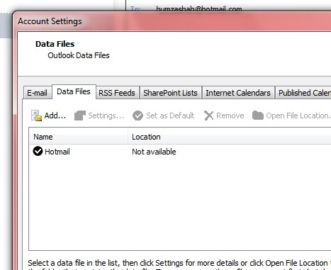

This Hotmail entry is where your email, calendars, and everything else is being saved. This entry opens up every time you open Outlook. You can choose to set a password on it, but somehow the old emails will still shows up. We need to create a new main Data File entry. Click on the “Add” button.

Step 3: An explorer window will open asking you to choose the location of your new Data File entry. Select aname and save it someplace on your hard disk. In this example we will be using the name “Main”.

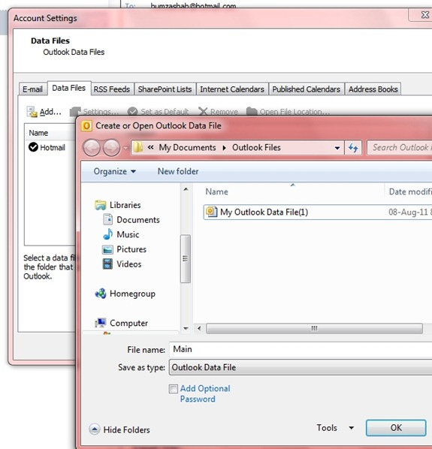
Step 4: “Main” will now appear as a Data File. Click on it to highlight and set it as the default location by using the button located above.
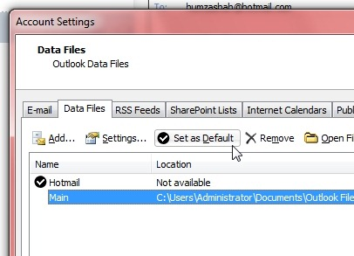
Step 5: Click on “OK” and then restart Outlook 2010.

Step 6: Head on over to the same Data Files tab, highlight Main and click on Settings.
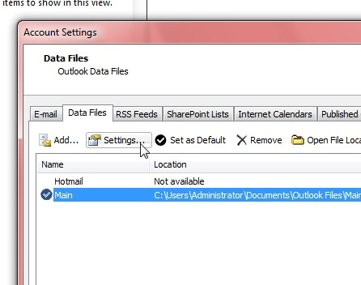

Step 7: In the subsequent window, click on the “Change Password” button.
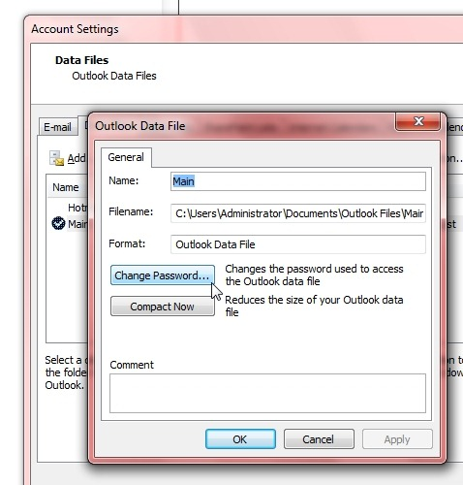
Step 8: Enter the password you want Outlook to require while opening. Leave the “Old password” field black and leave the checkbox you see unchecked.
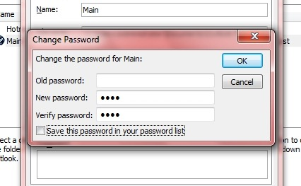

Step 9: Confirm your changes by clicking on the OK buttons and restart Outlook 2010.

Step 10: When Outlook 2010 opens, it will ask you for the password you set earlier.
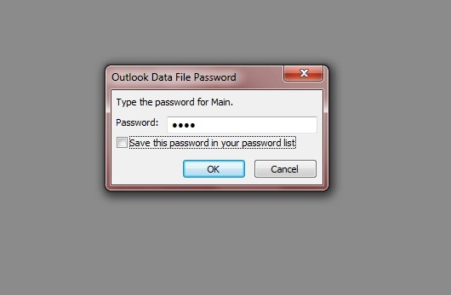

In the background you will see a gray screen that reveals nothing about your email. In other words, if you would like to read your email through Outlook, you will need to enter this password. In case you clicked on the “Cancel” button an error will show up and Outlook will exit.
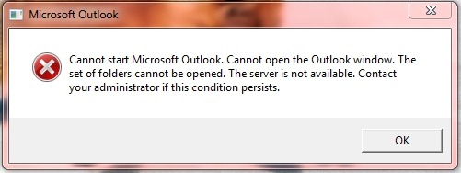

In these simple steps, you can effectively password-protect your Outlook 2010.

