Article: Using and Configuring Remote Assistance
Date: 01/03/2012
Posted by: HeelpBook Staff
Source: Link
Permalink: Link

Remote Assistance is a feature that was introduced in Windows XP that enables a user on one computer to remotely view and even take control of the desktop environment of another user's computer. The interaction between the two computers is initiated either through an invitation or through an offer of assistance from one user to the other.
For organizations that have deployed Windows XP in their desktop environment, Remote Assistance is a valuable tool for help desk departments.
Many service calls that once required a visit to the end user to resolve a problem can now be resolved interactively through a Remote Assistance session.
Carrying the functionality forward, the Remote Assistance tool is also available to Windows Server 2003. Whereas Remote Assistance is a valuable tool for the help desk in a desktop environment, it becomes a valuable collaborative tool for system administrators in the server environment. Using Remote Assistance, an administrator of one server can request or offer remote assistance to an administrator of another server.
The two administrators can then collaboratively resolve server configuration issues in real time through the same GUI on the server in question without having to be physically at the server.
This section describes how to configure and use the Remote Assistance tool to carry out collaborative remote administrative sessions on Windows Server 2003 servers.

Requirements for Remote Assistance
To take advantage of Remote Assistance, both machines engaging in a collaborative session must be running either the Windows XP or Windows Server 2003 operating system. Additionally, both machines must be connected via a common network. What makes Remote Assistance so flexible is that the common network can be the Internet.
If the collaborative session is initiated by one administrator sending an invitation to the other administrator, the computer sending the invitation must be able to transfer a file. The file can be transferred through e-mail, or automatically through the Help and Support Center, which uses Outlook Express or Windows Messenger. The file can also be saved and transferred by any other means of transferring a file.
If the collaborative session is initiated by an offer to assist, thus bypassing the invitation, then both computers must be in the same domain or be members of two trusting domains. Additional configurations are necessary for a machine to accept Remote Assistance offers, which will be discussed later in the section.
To use Remote Assistance in Windows Server 2003, it must be enabled. For security purposes, it is disabled by default. To enable Remote Assistance, perform the following steps:
- Open the System applet in the Control Panel.
- Go to the Remote tab, and click the check box to Turn on Remote Assistance and Allow Invitations to be Sent from This Computer.
- Click the Advanced tab, and enable the Remote Control feature and the invitation expiration, as shown in Figure 1.0…
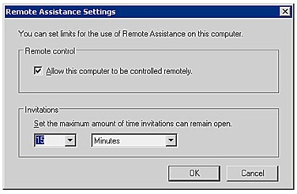

Sending a Remote Assistance Invitation
This section steps through the process by which a collaborative session is initiated through an invitation for Remote Assistance. The invitation can be sent in one of three ways:
- Using Windows Messenger. Windows Messenger is the preferred method for sending the invitation for assistance because it provides additional ways for the two machines to find each other over the Internet. If the two computers are on separate networks, separated by firewalls, and/or use Network Address Translation (NAT), this is the method to use.
- Sending an e-mail. Remote Assistance uses Simple Mail Advanced Programming Interface (MAPI) to help compose the invitation. The inviter or "Novice" sends an e-mail to the invitee or "Expert" with an attachment. When the Expert opens the attachment, he is prompted for a password, providing that the Novice specified a password, and the process continues.
- Saving and transferring a file. This method is used if there is no compatible MAPI client installed, or if other prerequisites are not available. This option enables the Novice to save the same file that would be created and attached to an e-mail automatically to be saved to her local drive or to a network share. The file can be transferred on a network share, a floppy disk, or other means. When the Expert receives the file, he can double-click it to open the invitation and start the Remote Assistance session.

Remote Assistance
If an e-mail client has not yet been configured, Remote Assistance attempts to help the Novice configure it. To change the e-mail client that Remote Assistance uses, in Control Panel, double-click Internet Options, and on the Programs tab, change the e-mail setting to the appropriate e-mail client. Some e-mail clients that do not support Simple MAPI will not appear as an option in the Internet Options Control Panel program.

To invite another administrator for Remote Assistance by sending a file, perform the following steps:
- Open Help and Support Center by clicking Start and then clicking Help and Support.
- Under Ask for Assistance click Invite a Friend to Connect to Your Computer with Remote Assistance.
- Click Invite Someone to Help You.
- Click Save Invitation as a File.
- Specify the Inviter's name, and an expiration time for the invitation, then click Continue.
- Type in a password that will unlock the invitation, retype the password for confirmation, and click Save Invitation.
- Select a location accessible to the Expert to save the file.
- When the Expert receives the invitation, the Expert is prompted for the password. After supplying this password, the Expert can initiate the Remote Assistance session.
- After the Expert initiates the session, the Novice's computer verifies the password that the Expert entered.
- The Novice's computer also checks to make sure that the invitation that the Expert used is a valid invitation and that the invitation is still open.
- If the invitation is open and the password is correct, the Novice receives a notification stating that the Expert wants to start the session now and the Novice is prompted to start the Remote Assistance session.
- If the Novice chooses to start the session, the Remote Assistance Novice chat dialog box will open on the Novice's computer, as shown in Figure 2.0, and the Remote Assistance Expert console opens on the Expert's computer. At this point, the Expert can see everything on the Novice computer, in real time.
- The Expert can request to take control of the Novice's computer at this point by clicking the Take Control button on the Expert console. This sends a message to the Novice's computer notifying the Novice that the Expert is requesting to take control of the computer.
- When the collaborative session is complete, the session can be ended by the Novice or Expert by clicking the Disconnect button.

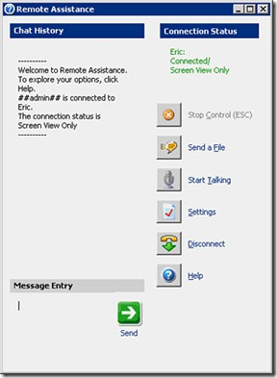
After the Expert Takes Control
After the Expert takes control, the Remote Assistance session responds to both users' inputs. As a result, the mouse might behave erratically if both the Expert and Novice are attempting to control the session.
If the Novice stops control, the Remote Assistance session continues and the Expert can still see the Novice's desktop.

