Article: Open Documents folder from Command Line
Date: 05/03/2012
Posted by: HeelpBook Staff
Source: Link
Permalink: Link

Microsoft Windows – Open my documents folder from command line
In Windows XP, we can use userinit command to open my documents folder in explorer.

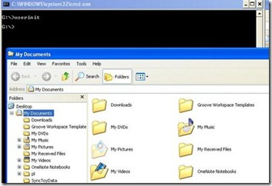

This command can be used from Run window also.
In Windows 7, ‘userinit‘ command opens the Libraries folder, which shows links to Documents, Pictures, Music and Video. To open Documents folder, we can run the command ‘Documents’ from Run window. However, this does not work from command prompt.
We can use ‘start documents‘ in command prompt to open the documents folder.

