Article: Add More Music Locations to Windows Media Player
Date: 09/01/2012
Posted by: HeelpBook Staff
Source: Link
Permalink: Link

Microsoft Windows - Add More Music Locations to Windows Media Player
Reader Jim has a laptop running Windows 7, and wants Windows Media Player to scan the music stored on an external hard drive and add it to his library.
No problem, Jim! But let's make sure to clarify a few things in this setup.
By default, Windows Media Player 12 looks for songs stored in the My Music and Public Music folders. On my system, that would be a problem right from the start, as I typically store my music in a folder called MP3s--one that's not stored in either of the aforementioned locations.
Fortunately, it's pretty easy to tell WMP to look elsewhere for music. Here's how:

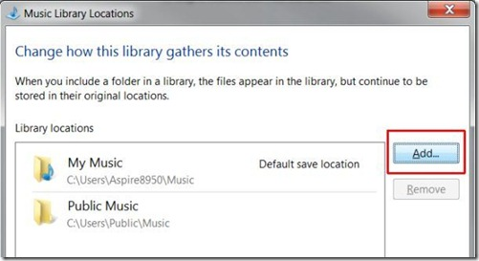

- Run Windows Media Player. (Note that I'm matching Jim's setup of Windows 7 and Windows Media Player 12).
- Click Organize, Manage libraries, Music.
- Click Add, then navigate to the folder you want to add. Click it, and then click Include folder.
Note those key words: "include folder". What you're telling WMP to do is scan the designated folder, then add those songs to your music library. However, no songs are actually copied or imported anywhere; they stay where they are.
Therefore, while it's no problem to add songs from an external drive, flash drive, network drive, or any other source, you have to make sure that source remains available, otherwise your songs won't play.
In other words, if you tell WMP to scan an external drive and then unplug that drive, you'll lose access to those songs.
The simple fix, of course, is to copy all that music to your laptop's hard drive, then let WMP update its library. If you don't have room, well, you'll have to leave that external drive connected and running.
Hope that answers your question, Jim.

