Date: 13/12/2012
Procedure: Marking a stored procedure as System Object (SQL Server)
Source: LINK
Permalink: LINK
Created by: HeelpBook Staff
Document Version: 1.0

Marking a stored procedure as System Object (SQL Server)

Marking a stored procedure as system object allows to run the procedure in a user database context. There are two requirements to allow running a procedure created in [master] database in user database context:

The stored procedure name must begin with “sp_” :

A stored procedure created with “sp_” prefix can be used in any user database without specifying database/schema. But, the procedure still run in the context of master database and not the user database. Let’s create a procedure to test this:

USE [master]
GO
CREATE PROCEDURE sp_Objects
AS
SELECT name, object_id, type_desc
FROM sys.objects
WHERE is_ms_shipped <> 1
GO
–Execute procedure in [master]
SELECT DB_NAME() ’Current Database’
EXEC sp_Objects
–-Execute procedure in [SqlAndMe]
USE [SqlAndMe]
SELECT DB_NAME() ’Current Database’
EXEC sp_Objects
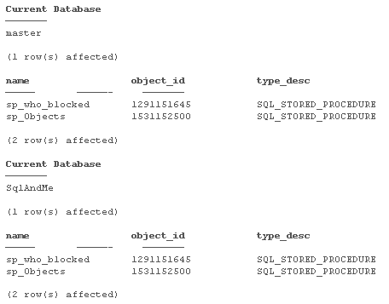

Result Set:

As you can see from the result set, the procedure sp_Objects runs under [master] even after switching the database using “USE DB”.

The stored procedure must be marked as system object explicitly:

You can mark a stored procedure as system object using sys.sp_MS_marksystemobject system procedure. Let’s mark our procedure sp_Objects as system object and re-execute above code.
Below code will mark the procedure as system object:
USE [master]
EXEC sys.sp_MS_marksystemobject sp_Objects

You can verify if the object is marked as system object:
USE [master]
SELECT name, is_ms_shipped
FROM sys.objects
WHERE name = ‘sp_objects’

Result Set:
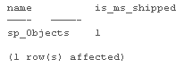
sp_Objects is now marked as system object and can be run in user database context:

–Execute procedure in [master]
USE [master]
SELECT DB_NAME() ‘Current Database’
EXEC sp_Objects
–Execute procedure in [SqlAndMe]
USE [SqlAndMe]
SELECT DB_NAME() ‘Current Database’
EXEC sp_Objects

Result Set:

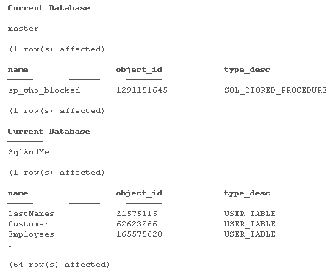

You can also create tables in master database which begin with prefix “sp_“, and these can be used in user databases without database/schema prefix. It does not need to marked as system object. Try below example yourself:

–Create Table in [master]
USE [master]
GO
SELECT DB_NAME() ‘Current Database’
CREATE TABLE sp_Table1
(
Col1 CHAR(10)
)
INSERT INTO sp_Table1
VALUES (‘Master’)
–Insert/Select from [SqlAndMe]
USE [SqlAndMe]
SELECT DB_NAME() ‘Current Database’
INSERT INTO sp_Table1
VALUES (‘SqlAndMe’)
SELECT *
FROM sp_Table1

Hope This Helps!

