Date: 24/12/2012
Procedure: Let user select a folder from script (Visual Basic)
Source: LINK
Permalink: LINK
Created by: HeelpBook Staff
Document Version: 1.0

Let user select a folder from script (Visual Basic)

This little code snippet will let you to let an end-user to select a folder to pass to the logic to let your script to decide, for example, how to behave or what to do (decided by the programmer, obviously).
On error resume next
SET fso=createobject(“scripting.filesystemobject”)
SET WshShell=WScript.CreateObject(“Shell.Application”)
dirPath=WshShell.BrowseForFolder(0, “Select the path”, &H4000, “”).items().item().path
IF right(dirPath,1)<>”\” THEN
dirPath=dirpath & “\”
END IF
IF dirpath=”\” THEN
dirpath=”You have to select a folder!”
END IF
msgbox dirpath

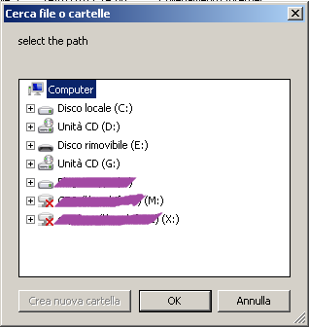

NOTE: this script use the BrowseForFolder method.

