Article: How To Use a Monitor as a Secondary Display
Date: 29/12/2011
Posted by: HeelpBook Staff
Source: Link
Permalink: Link

How To - Use a Monitor as a Secondary Display for your Laptop

There is one thing people from almost every level try to increase. That is productivity. People do a lot of things to increase their productivity.
For freelancers, they choose a separate workspace and a clutter-free desktop to be productive. Some block social networking websites to stay productive. There’s one more thing people do, that is increasing the number of displays.
Yes, I’m talking about dual monitor computers. Sometimes this is a requirement, sometimes it’s just for convenience. However, many of us can’t afford a dual-display desktop. But if you have a laptop, you can get the taste of dual display computer by connecting the monitor to your laptop as a secondary display.

How to Connect the Monitor
In your laptop, you’ll find a jack to connect the monitor port. It’s mainly used for projectors, but you can connect your monitor in there. As soon as you connect, if the power of your monitor is on, you’ll see your desktop is shown on the monitor.
However, you’ll also notice that the same display is shown on both your laptop’s screen and the external monitor.
There’s some settings to be done in order to separate out the external monitor from behaving like a duplicate display.

Settings
Right now, I’m on a Windows 7 computer. Many people that I know of have upgraded to Windows 7 because of its increased security, stability and eye-candy. I’ll cover here how to set the external monitor as a secondary display in Windows 7.
First of all, right click on your desktop and click “Screen Resolution”. On Windows XP, it will be “Properties” and then “Settings”. You’ll see a window identical to the following one (while your secondary display is plugged in).

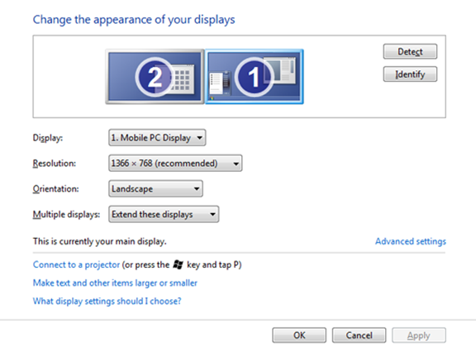

Now, first you need to identify the display. By default, your laptop screen should be the first and external monitor should be the second. The Display drop-down menu will help you figure it out.
If you’re still confused, simply click the Identify button to see what number is assigned to both displays.
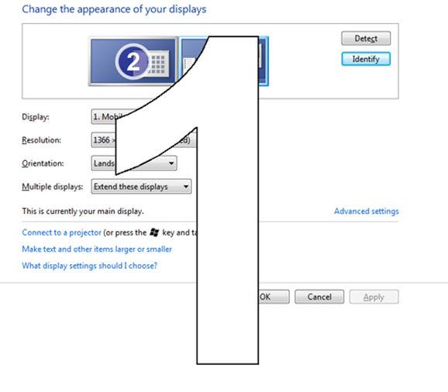

Now, in the Multiple displays pull down menu, select Extend these displays option. You’ll now see the display has been extended. However, you may face a problem with primary and secondary displays. When I first tried this, I noticed all my desktop icons and start menu moved to the secondary display.
So I needed to grab them back to my laptop screen. Go to Advanced Settings and set 1 as your main display. Once you do this, you’ll see all the desktop icons and start menu are back on your laptop screen.

Arrange Your Displays
Let’s imagine you have put your laptop on the right side of you and the external monitor is on your left. It’d be awkward if your computer extends to your right instead of left. To check that, simply open up a window and drag it all the way to the left (towards where the secondary monitor is physically placed).
If you don’t see the edge of the window showing up on the secondary display, then you need to rearrange your displays.
On the same window we opened above, you can see two screens are shown with their assigned numbers. You can click and drag them the way they actually are in front of you. So if your external monitor is on your left, you need to drag and drop the display icon that represents 2 on the left.
I hope it has been easy for you to follow the instructions. If you succeeded, you now have a dual display computer.
Enjoy your secondary display.

