Date: 20/02/2013
Procedure: How to use special batch DOS parameters (DOS programming)
Source: LINK
Permalink: LINK
Created by: HeelpBook Staff
Document Version: 1.0

How to use special batch DOS parameters (DOS programming)

To determine the relative path of the current directory to the script, and then change to that directory. Try including this simple code in a .bat file and run it:

set REL_DIR=%~d0%~p0
pushd %REL_DIR%
echo %REL_DIR%
pause >nul

The %~d0 will select the drive (volume) on which the script resides, while the %~p0 will select the relative path of the script.

To use a modifier, type the percent (%) character followed by a tilde (~) character, and then type the appropriate modifier (that is, %~modifier).
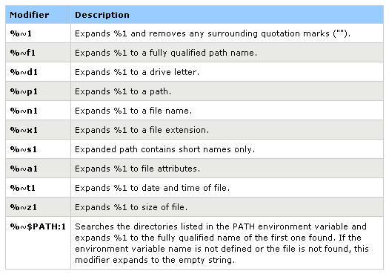
Batch DOS Parameters
The following table lists possible combinations of modifiers and qualifiers that you can use to get compound results.
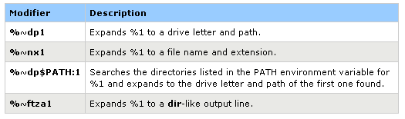
Batch DOS Parameters combination

