Date: 05/06/2012
Procedure: How to disable Internet Explorer Error Reporting
Source: LINK
Permalink: LINK
Created by: HeelpBook Staff
Document Version: 1.0

How to disable Internet Explorer Error Reporting

Internet Explorer Error Reporting reports crashes to Microsoft everytime the browser crashes, most of the time due to an addon or a browser extension. Mostly, we would not want to send the info to microsoft and click “Don’t send” in which case this can be quite annoying.
Internet Explorer Error reporting can be disabled from the registry.

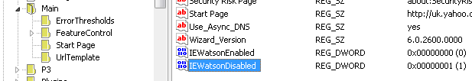

To disable, try the following:
NOTE: This should work in Internet Explorer 5.5, 6, 7, 8
1. Click Start – Run, type REGEDIT and click OK.
2. In the registry editor, navigate to:
3. Create a DWORD called “IEWatsonEnabled” and set its value as 0.
NOTE: To create a DWORD, right-click on the right pane and select New and then DWORD and name it as said. To set the value, right-click the DWORD and select Modify;

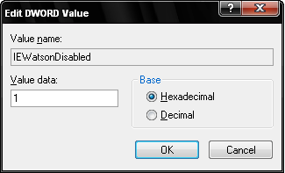
4. Similarly create another DWORD named “IEWatsonDisabled” and set is value as 1.
5. Close the Windows Registry Editor and restart the computer for the changes to take effect.
This will disable error reporting in Internet Explorer.

