Date: 06/07/2012
Procedure: How to disable ActiveSync Partnership popup dialog
Source: LINK
Permalink: LINK
Created by: HeelpBook Staff
Document Version: 1.0

How to disable ActiveSync Partnership popup dialog

The ActiveSync have a "secret" registry key that associate connected device as guest. To disable the ActiveSync Partnership dialog popup by doing following steps.

Set "GuestOnly"=dword:1 is to disable ActiveSync Partnership dialog popup:
[HKEY_LOCAL_MACHINE\Software\Microsoft\Windows CE Services]
"GuestOnly"=dword:1
Set "GuestOnly"=dword:0 is to enable ActiveSync Partnership dialog popup:
[HKEY_LOCAL_MACHINE\Software\Microsoft\Windows CE Services]
"GuestOnly"=dword:0
In Windows XP, click Start->Run to startup Run Dialog box. Type in regedit and press OK to open Registry Editor window.
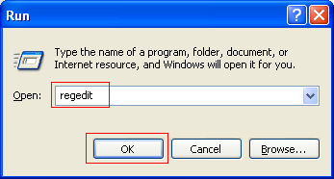

Go to [HKEY_LOCAL_MACHINE\Software\Microsoft\Windows CE Services] registry key, and add "GuestOnly"=dword:1 registry key.

Save and exit the regedit editor.
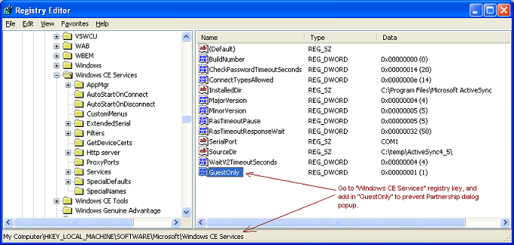

Now, if you plug-in Windows CE or Windows Mobile, you won’t see the ActiveSync Partnership dialog popup.

