Date: 14/07/2012
Procedure: How to connect a PDA / Pocket PC to Exchange Server
Source: LINK
Permalink: LINK
Created by: HeelpBook Staff
Document Version: 1.0

For a PDA’s already in use:

• Delete the exiting Partnership
1. Disconnect your Pocket PC from your desktop.
2. Open Active Sync.
3. Select File, then select Delete Partnership:
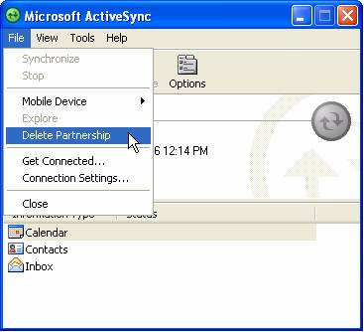

4. Connect your device and set up a new partnership, as described under On first time use, below;
On first time use:
Install the application ActiveSync on your PC. When you connect your PDA to your computer, ActiveSync will respond with the following screens, which will now used through several steps to install a so-called Root Certificate.

1. Connect your device your PC; ActiveSync responds with the following screens:
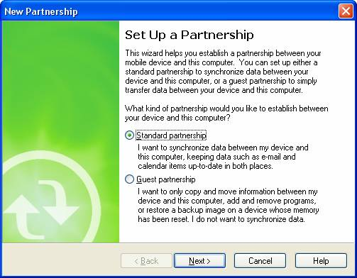
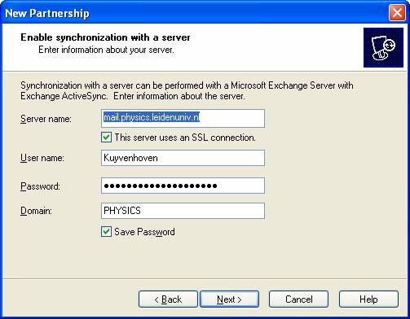
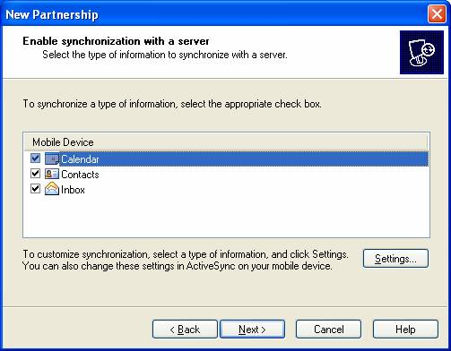
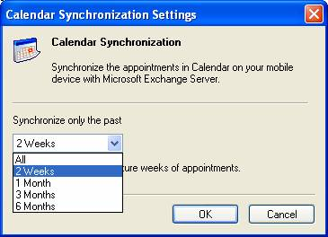
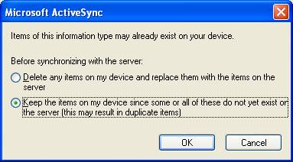
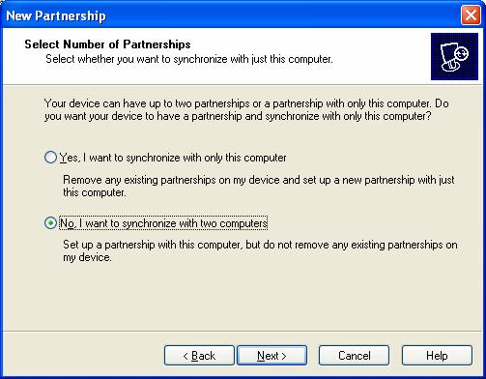
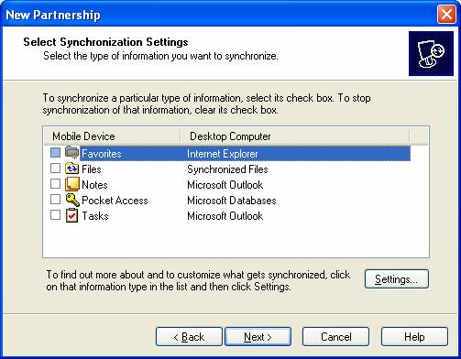
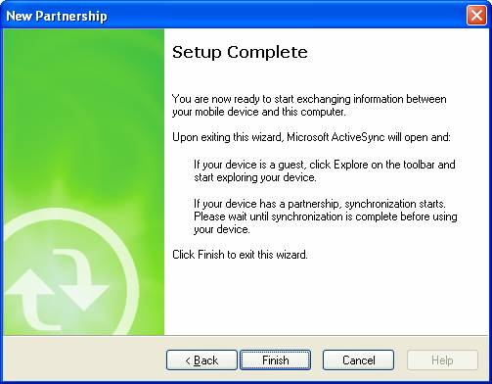
2. Open Windows Explorer on your desktop, and locate your Pocket PC device.

3. Download the Addrootcert.exe file and copy it to your Pocket PC 2002 device, and store it the \Windows\Start menu folder, so it can be seen in the Windows Start menu.

4. Download your certificate, and copy it to one of your PDA folders
Note: If you use a storage card, copy Addrootcert.exe to the My Documents folder on the card. If you have multiple devices, you can now use this card to run Addrootcert.exe on each device.

5. Run the Addrootcert.exe application.

6. Click Open, and then click the .cer file that you want. Click the Install Certificate button to add the certificate to the root store.

7. Do a soft reset on the device to make sure that it registers the new certificate.
