Date: 25/06/2012
Procedure: How to check SQL Server version
Source: LINK
Permalink: LINK
Created by: HeelpBook Staff
Document Version: 1.0

How to check SQL Server version

The most common way to check SQL Server is to use @@VERSION configuration function. It returns version, architecture, OS version and build date for current instance.
SELECT @@VERSION AS [Version]
Version
—————————————
Microsoft SQL Server 2008 R2 (RTM) – 10.50.1600.1 (Intel X86) Apr 2 2010 15:53:02 Copyright (c) Microsoft Corporation Enterprise Edition on Windows NT 6.0 <X86> (Build 6002: Service Pack 2)
(1 row(s) affected)
Another way is to use SERVERPROPERTY() metadata function. For a full list of properties that can be returned, check BOL.
SELECT SERVERPROPERTY('ProductVersion') AS [Version]
Version
—————————————
10.50.1600.1
(1 row(s) affected)

You can also use extended stored procedures to check SQL Server version:

sp_MSgetversion
EXEC master..sp_MSgetversion
Character_Value
——————– ———– ———–
10.50.1600.1 1 3
(1 row(s) affected)

xp_msver
EXEC master..xp_msver 'ProductVersion'
Index — Name — Internal_Value — Character_Value
—— ——————————– —
2 — ProductVersion — 655410 — 10.50.1600.1
(1 row(s) affected)
To see the full list of properties returned by xp_msver, execute it without any arguments.
EXEC master..xp_msver
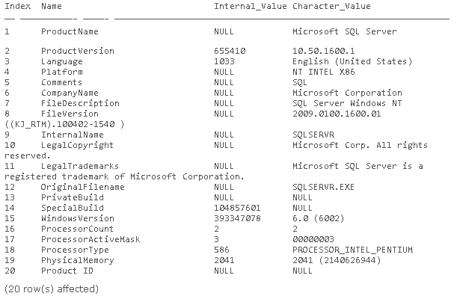

xp_instance_regread
DECLARE @returnValue NVARCHAR(100)
EXEC master..xp_instance_regread
@rootkey = N'HKEY_LOCAL_MACHINE',
@key = N'SOFTWARE\Microsoft\MSSQLServer\Setup',
@value_name = N'Version',
@value = @returnValue output
SELECT @returnValue AS [Version]
Version
—————————————————————————————————-
10.50.1600.1
(1 row(s) affected)

