Date: 18/02/2013
Procedure: How to automatically log off disconnected Remote Desktop terminal services sessions
Source: LINK
Permalink: LINK
Created by: HeelpBook Staff
Document Version: 1.0

How to automatically log off disconnected Remote Desktop terminal services sessions (Microsoft)

I’ve frequently heard complaints about people forgetting to log off when they end a Remote Desktop session. Instead they simply close the window, leaving their session running on the server.

This orphaned session becomes a problem in many cases because Windows Servers are typically only licensed for two simultaneous logged in users. Even worse, if you can’t remote into the box, you may not be able to easily identify the culprit(s) who left their sessions active. This leaves you no-one to throw things at and generally a very grumpy person.

Fortunately there is a solution to this problem…
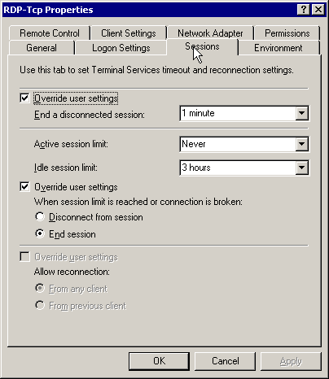
Windows Server - Terminal Services options
You can configure Terminal Services to terminate abandoned sessions fairly easily on Windows 2000 and 2003 servers by doing the following:

- On the server, go to “Start > Programs > Administrative Tools > teminal Services Configuration“
- Select “Connections“, then right click on RDP-Tcp and select Properties
- Select the Sessions tab and Check the “Override user settings” checkbox.
- Choose the criteria under which you’d like to start killing off sessions.

That does it!

