Date: 28/11/2012
Procedure: How to Remove Film Strip (Video Sprockets) From Video Thumbnails
Source: LINK
Permalink: LINK
Created by: HeelpBook Staff
Document Version: 1.0

How to Remove Film Strip (Video Sprockets) From Video Thumbnails (Windows 7)

Thumbnails for video files in Windows 7 contain a film strip overlay on the sides which consumes part of the thumbnail image. If you need to remove the video sprockets / film strip effect, there is a registry setting you need to change.

Click Start, type regedit.exe and press {ENTER}

Navigate to the following key:
HKEY_CLASSES_ROOT\SystemFileAssociations\video
In the right-pane, double-click Treatment and set its value data to 0.
Here are the possible values…
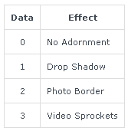

Exit the Registry Editor.

Logoff and log back in to your account. Filmstrips are now gone!

