Date: 21/05/2012
Procedure: How to Disable/Delete unwanted Internet Explorer Toolbars & Extensions
Source: LINK
Permalink: LINK
Created by: HeelpBook Staff
Document Version: 1.0

Microsoft Windows – How to Disable or Delete unwanted Internet Explorer Toolbars and Extensions

There will always be instances where you are not able to uninstall or disable a Toolbar directly from your Internet Explorer browser. While this can be menacing and troublesome, there can also be some toolbar extensions that sit there hiding causing security issues.
Windows Registry can be one other place from where you can delete these toolbars and browser extensions. The procedure discussed in this article should work on Windows 2000, Windows XP, Windows 2003 and later.
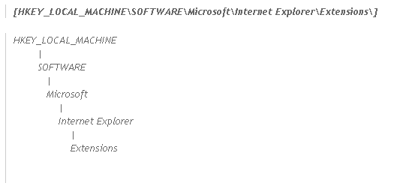
To delete unwanted Internet Explorer toolbars and extensions from Windows Registry,please try the following:
WARNING: Editing Windows Registry can have serious consequences.
You are editing at your own risk.
1. Click Start – Run
2. Type “regedit” and press enter to launch the Windows Registry Editor.
3. On the left panel, Navigate to the key
4. You will see all the Internet Explorer Extensions as subkeys here (as subfolders). Click on any of them, it will show the list of registry keys associated with it. For example, for MSN messenger, the extension key is:

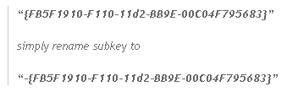
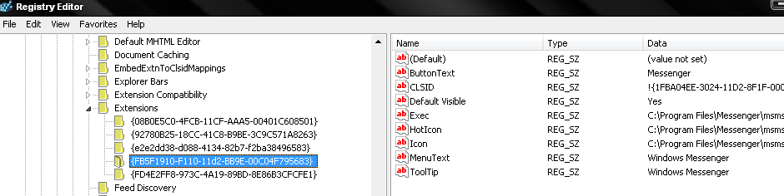
This will disable the internet explorer browser extension. If you do not need it at all, simply delete the subkey.
This procedure will help you identify, disable/delete the browser extension from your Internet Explorer.

