Article: How to Copy a DVD Movie
Date: 03/02/2012
Posted by: HeelpBook Staff
Source: Link
Permalink: Link

How to Copy a DVD Movie
What would you do if you lost your entire movie collection? Wouldn’t it be nice to have some backups laying around in case someone scratched your precious Rudy video or your dog ate an entire season of the Simpsons?
A popular application called DVD Decrypter lets you copy an entire DVD onto your computer’s hard drive, and it bypasses any copy protection mechanisms that would make duplicating a store-bought DVD otherwise impossible.
The only problem is that new copy protection algorithms are frequently being created, and this application hasn’t been updated since 2005.
For that reason you should use Free DVD (kudos to xpgeek in the forum for pointing this out). It can copy an entire movie to the hard disk while removing all traces of copy protection (CSS, RC, RCE, APS, UOPs and Sony ARccOS). This application is frequently updated, and best of all it’s not hard to use nor does it require any installation.
How you copy a DVD movie:
- Put the movie you want to copy in the DVD drive of your computer. Open up the contents of the DVD using a file explorer, such as Windows Explorer, and copy the VIDEO_TS folder to a location on your hard drive.

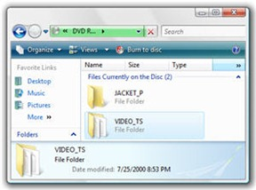

- Download and run Free DVD (the free version, not the Platinum). It’s only 44KB, and doesn’t require any installation.
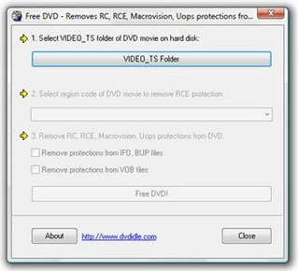
- In Free DVD, select the VIDEO_TS folder you copied to your hard drive in the first step. You’ll receive a prompt notifying you of the restrictions that will be removed.
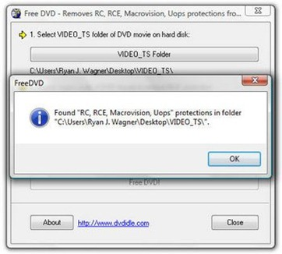
- You probably won’t need to adjust any of the settings, but go ahead and do so if it’s needed. Then press the Free DVD! button to remove all copy restrictions from the movie.
- Then if you want to put this video on a DVD you can use DVD Shrink. This program will also remove copy protections, but it is well over a year old and you’ll probably run into some DVD’s that it doesn’t work with. If you use Free DVD first then all of your issues should be solved. The great thing about DVD Shrink is that it will also cut down the size of the video so that it will fit on a normal DVD instead of needing a dual-layer disc.
Backing up your DVD’s has never been so easy! Now remember, these instructions are for educational purposes only, and I guess they should only be used on your own home-made movies that you apply copy protection to.

