Date: 19/10/2012
Procedure: How can I open a message box in a Windows batch file?
Source: LINK
Permalink: LINK
Created by: HeelpBook Staff
Document Version: 1.0

How can I open a message box in a Windows batch file?

SCENARIO

My question is: how can I make a batch file open a popup screen?

Like:

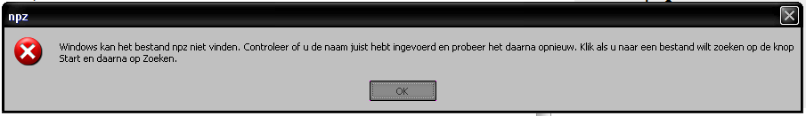

METHOD 1

Something like the following saved in MessageBox.vbs (from simple .txt to .vbs):
Set objArgs = WScript.Arguments
messageText = objArgs(0)
MsgBox messageText
Which you would call like:
cscript MessageBox.vbs "This will be shown in a popup."

METHOD 2

This way your batch file will create a VBS script and show a popup. After it runs, the batch file will delete that intermediate file.
The advantage of using MSGBOX is that it is really customazable (change the title, the icon etc).
echo MSGBOX "YOUR MESSAGE" > %temp%\TEMPmessage.vbs
call %temp%\TEMPmessage.vbs
del %temp%\TEMPmessage.vbs /f /q

