Date: 22/02/2013
Procedure: Host Resolution Priority Tweak (DNS e file HOSTS)
Source: LINK
Permalink: LINK
Created by: HeelpBook Staff
Document Version: 1.0

Host Resolution Priority Tweak (DNS e file HOSTS)

The tweak desribed below helps boost priority for DNS & hostname resolution in general. What this means is, it helps web pages load faster, and has negligible effect on downloads (not counting the couple of ms gain with the host resolution at connect-time).

What we’re aiming at is to increase the priority of 4 processes, while keeping their order. Lower numbers mean higher priority compared to other services.
Let’s examine these 4 services:
- LocalPriority = 499 default default priority – local names cache
- HostPriority = 500 default priority – the HOSTS file
- DnsPriority = 2000 default priority - DNS host resolution
- NetbtPriority = 2001 default priority - NetBT name resolution, including WINS

For these four services (all related to host name resolution), you will see some people recommending using the same priority, usually 1,1,1,1. The problem with that is it does not keep the correct order of priorities for the different services.

That is why we recommend using small consecutive numbers, as the examples below. Using 5,6,7,8 increases their priority significantly compared to all other services (and their own default values) while keeping their correct order.

Applying this tweak assumes some proficiency in editing the Windows Registry using Regedit (Start > Run > type: regedit).
Reboot after making changes. As always, backup your Registry before making any changes so you can revert to the previous state if you don’t like the results.

Note: The below host name resolution tweak can also be used for changing name-resoluton order besidespriority.

Windows 2k/XP
First, open the Windows Registry using Regedit, and (after backing up) navigate to:
HKEY_LOCAL_MACHINE\SYSTEM\CurrentControlSet\Services\Tcpip\ServiceProvider
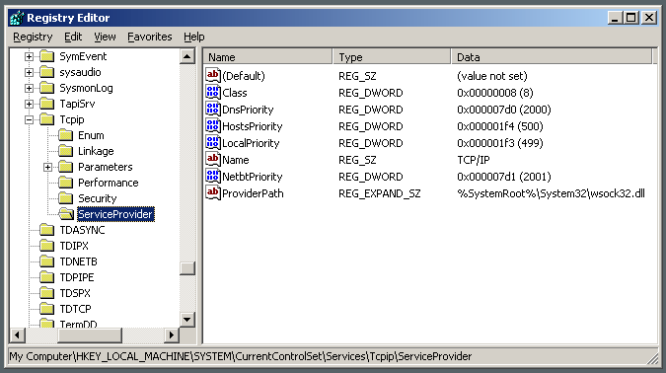
DNS Boosts Name Resolution process

Note the following lines (all hex dwords):

Class = 008 (8) - indicates that TCP/IP is a name service provider, don’t change.

- LocalPriority = 1f3 (499) - local names cache
- HostsPriority = 1f4 (500) - the HOSTS file
- DnsPriority = 7d0 (2000) – DNS
- NetbtPriority = 7d1 (2001) - NetBT name-resolution, including WINS
What we’re aiming to do is increase the priority of the last 4 settings, while keeping their order. The valid range is from -32768 to +32767 and lower numbers mean higher priority compared to other services.
What we’re aiming at is lower numbers without going to extremes, something like what’s shown below should work well:

Change the “Priority” lines to:

- LocalPriority = 005 (5) - local names cache
- HostsPriority = 006 (6) - the HOSTS file
- DnsPriority = 007 (7) - [gs DNS
- NetbtPriority = 008 (8) - NetBT name-resolution, including WINS
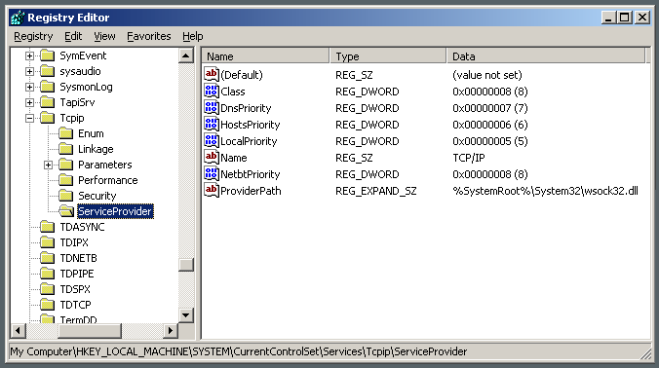
DNS Boosts Name Resolution process

As usual, reboot for changes to take effect.

Windows 9x/ME
The tweak is essentialy the same as in Windows 2000/XP, just the location in the Registry is slightly different. For a more detailed description see the Windows 2000/XP section above.
Open the Windows Registry using Regedit, and (after backing up) navigate to:
HKEY_LOCAL_MACHINE\System\CurrentControlSet\Services\VxD\MSTCP\ServiceProvider
You should see the following settings:
Class=hex:08,00,00,00

- LocalPriority=hex:f3,01,00,00
- HostsPriority=hex:f4,01,00,00
- DnsPriority=hex:d0,07,00,00
- NetbtPriority=hex:d1,07,00,00
The “priority” lines should be changed to:
- LocalPriority=hex:05,00,00,00
- HostsPriority=hex:06,00,00,00
- DnsPriority=hex:07,00,00,00
- NetbtPriority=hex:08,00,00,00
Reboot for changes to take effect.

Windows Vista / 2008 Server
As with previous versions of Windows, one can improve DNS and hostname resolution by increasing the priority of of related services, while keeping their order.
Lower numbers mean higher process priority. The corresponding registry settings in Vista are as follows:
HKEY_LOCAL_MACHINE\SYSTEM\CurrentControlSet\Services\Tcpip\ServiceProvider
- LocalPriority=4 (DWORD, recommended: 4, default: 499) – local names cache
- HostsPriority=5 (DWORD, recommended: 5, default: 500) – the HOSTS file
- DnsPriority=6 (DWORD, recommended: 6, default: 2000) – DNS
- NetbtPriority=7 (DWORD, recommended: 7, default: 2001) - NetBT name resolution, including WINS

