Article: Create a glowing border around an Input Field
Date: 02/01/2012
Posted by: HeelpBook Staff
Source: Link
Permalink: Link

HTML/CSS - Create a glowing border around an Input Field

SCENARIO
I want to create some decent inputs for my form, and I would really like to know how TWITTER does their glowing border around their inputs.
I also don't quite know how to create the rounded corners :-/

SOLUTION (1)
Here you go:
input {
border:2px solid #dadada;
border-radius:7px;
font-size:20px;
padding:5px;
}
input:focus {
outline:none;
border-color:#9ecaed;
box-shadow:0 0 10px #9ecaed;
}

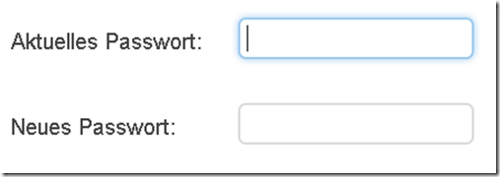

SOLUTION (2) by HeelpBook Staff
If you want a better compatibility through multiple browsers and even an HOVER effect (when mouse is over your input form) you could use the following code:

input {
border:2px solid #dadada;
border-radius:7px;
font-size:20px;
padding:5px;
}

input:focus {
outline:none;
border-color:#9ecaed;
box-shadow:0 0 10px #9ecaed;
-moz-box-shadow: 0px 0px 4px #9ecaed;
-webkit-box-shadow: 0px 0px 4px #9ecaed;
}

input:hover {
outline:none;
border-color:#9ecaed;
box-shadow:0 0 10px #9ecaed;
-moz-box-shadow: 0px 0px 4px #9ecaed;
-webkit-box-shadow: 0px 0px 4px #9ecaed;
}

