Article: How to link Table to ListBox using VBA
Date: 03/01/2012
Posted by: HeelpBook Staff
Source: Link
Permalink: Link

Fill a ListBox from Excel Table using VBA / Populate a ListBox from Excel Table using VBA
Let us take a Excel table as shown below - a list of Top 10 All time hits.
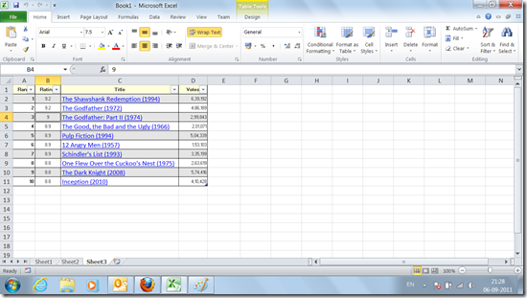

Let us assume that we need to populate the Listbox with values from Column 3 (Column C)…

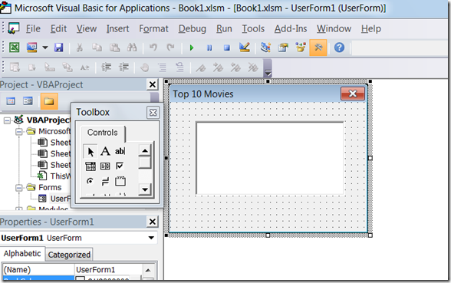
The following code will help you populate the data:

Dim oWS As Worksheet
Set oWS = ThisWorkbook.Sheets(3)
Me.ListBox1.List = oWS.ListObjects(1).ListColumns("Title").DataBodyRange.Value
End Sub

