Date: 27/04/2012
Procedure: Excel - Finding the Maximum Value in Each Column in a Range
Source: LINK
Permalink: LINK (http://heelpbook.altervista.org/2012/excel-finding-the-maximum-value-in-each-column-in-a-range/)
Created by: HeelpBook Staff
Document Version: 1.0

Excel – Finding the Maximum Value in Each Column in a Range

The following function will return the Maximum Value in each Column in a Range:

Function Max_Each_Column(Data_Range As Range) As Variant
Dim TempArray() As Double, i As Long
If Data_Range Is Nothing Then Exit Function
With Data_Range
ReDim TempArray(1 To .Columns.Count)
For i = 1 To .Columns.Count
TempArray(i) = Application.Max(.Columns(i))
Next
End With
Max_Each_Column = TempArray
End Function

We can use a subroutine like the following to display the results:

Private Sub CommandButton1_Click()
Dim Answer As Variant
Dim No_of_Cols As Integer
Dim i As Integer
No_of_Cols = Range("B5:G27").Columns.Count
ReDim Answer(No_of_Cols)
Answer = Max_Each_Column(Sheets("Sheet1").Range("B5:g27"))

For i = 1 To No_of_Cols
MsgBox Answer(i)
Next i
End Sub

So:
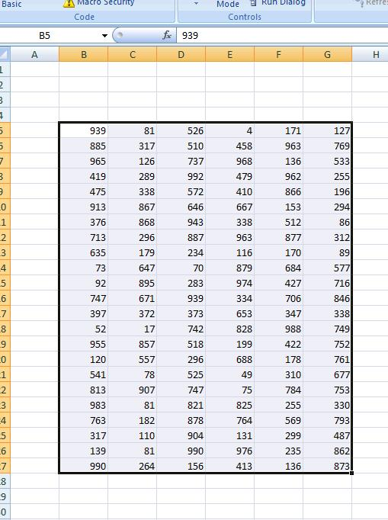
Will return 990,907, 992, 976 ,988 and 873 for each of the above columns.

