Date: 11/12/2012
Procedure: Disable the lock screen (Windows 8)
Source: LINK
Permalink: LINK
Created by: HeelpBook Staff
Document Version: 1.0

Disable the lock screen (Windows 8)

If you like your PC to boot just as fast as possible then the new Windows 8 lock screen may not appeal. Don’t worry, though, if you’d like to ditch this then it only takes a moment.

• Launch GPEdit.msc (the Local Group Policy Editor) and browse to Computer Configuration > Administrative Templates > Control Panel > Personalisation.

• Double-click ‘Do not display the lock screen‘, select Enabled and click OK.

• Restart and the lock screen will have gone.

If you can’t easily find GPEdit.msc by searching in the Start screen, search for ‘mmc‘, and then press Enter.

On the File menu, click ‘Add/Remove Snap-in‘, then in the ‘Add or Remove Snap-ins‘ dialog box, click ‘Group Policy Object Editor‘, and then click ‘Add‘.

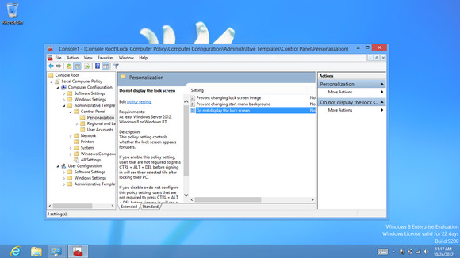

In the ‘Select Group Policy Object‘ dialog box, click ‘Browse‘. Click ‘This Computer‘ to edit the Local Group Policy object, or click ‘Users‘ to edit Administrator, Non-Administrator, or per-user Local Group Policy objects, then click ‘Finish‘.

