Date: 12/12/2012
Procedure: Boot to the desktop without an App (Windows 8)
Source: LINK
Permalink: LINK
Created by: HeelpBook Staff
Document Version: 1.0

Boot to the desktop without an App (Windows 8)

One of biggest complaints about Windows 8 is that it boots straight to the Start screen…an annoyance for many committed desktop users.

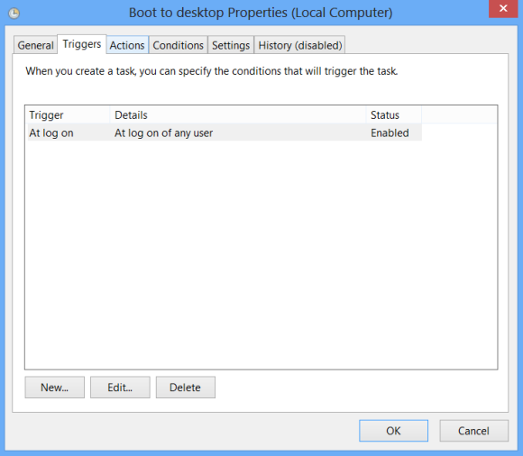

The Start8 utility helps you avoid this indignity (among other cool features), but you can actually boot straight to the desktop without installing anything extra.

• Go to the start screen and type in “schedule” to search for Schedule Task in Settings.
• Click on Task Scheduler Library to the left, and select Create Task.
• Name your task something like “Boot to desktop“.
• Now select the Triggers tab, choose New, and use the drop-down box to select starting the task “At log on” .
• Click OK and go to the Actions tab, choose New, and enter “explorer” for the Program/Script value.

Press OK, save the task, and restart to test it out!

