Article: How to set up Wi-Fi Sync for iOS 5
Date: 05/01/2012
Posted by: HeelpBook Staff
Source: Link
Permalink: Link

One of the biggest changes iOS 5 brings for iPhone, iPad, and iPod Touch users is Wi-Fi Sync. With it, you no longer need to physically connect your iOS device to your Mac or PC to sync its contents with iTunes. Instead, you need only to be on the same Wi-Fi network for iTunes to see your device and sync it. Here's how it works.

If you are running iTunes 10.5 and have successfully installed iOS 5, there is but a single box to check in iTunes to set up Wi-Fi Sync. First, connect your device via USB (one last time) to your Mac or PC. Next, click on the device's name in the left-hand column of iTunes. Make sure Summary is selected from the row of menu items along the top of iTunes and scroll down until you see Options. Check the box for the second option listed, "Sync this iPhone/iPad/iPod Touch over Wi-Fi" and click the Apply button in the lower-right corner.

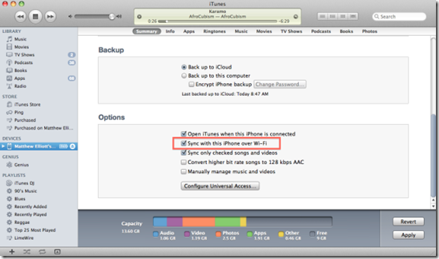

Disconnect your device and the next time you plug it into a wall outlet, iTunes will initiate a sync over your Wi-Fi network. Do note that iTunes will need to be running when you plug in your iOS handset.
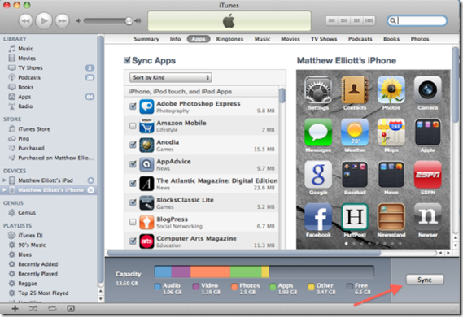
If you click the Sync button, your iOS device will sync without needing to be connected to a power outlet.

Alternatively, you can sync an iOS device from your PC or Mac without the device plugged in. If you have installed new apps since your last sync, you'll see a Sync button in the lower-right corner of your devices Summary page in iTunes. (If nothing has changed since your last sync, you'll instead see Revert and Apply buttons there). Click Sync and iTunes will sync with the device, whether it's plugged in or not.

