Date: 05/07/2012
Procedure: ActiveSync - How to reestablish a partnership
Source: LINK
Permalink: LINK
Created by: HeelpBook Staff
Document Version: 1.0

ActiveSync – How to reestablish a partnership

Overview:

If your Pocket PC has experienced a reset and loses its data, you can use your old ActiveSync partnership by creating a new one and using the same name as the previous one.

Go to the Start > Settings > System tab > About > Device ID screen and type in the old name in the field.

Procedure

Here’s how to do it:
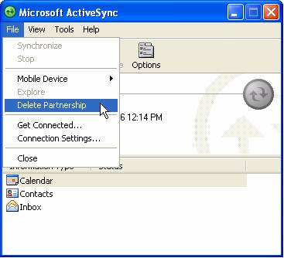

- Make sure your Pocket PC is NOT cradled or connected to the PC.
- Go to the About setup screen (Start > Settings > System tab > About) and tap on the tab labeled Device ID at the bottom of the screen.
- Enter the old name of the device in the data field labeled "Device name".
- Remove the old partnership from the ActiveSync window on your desktop PC by going to File > Delete Mobile Device (or Delete Partnership).
- Connect your Pocket PC to your desktop PC and reestablish the partnership. You’ll have your old partnership name back and you should be able to restore the device from the backup/restore file. (Note: Backup/restore feature is only available on pre-Windows Mobile 5.0 devices.)

